Y5 English Homework week 3 (23.1.25)

Galileo Galilei
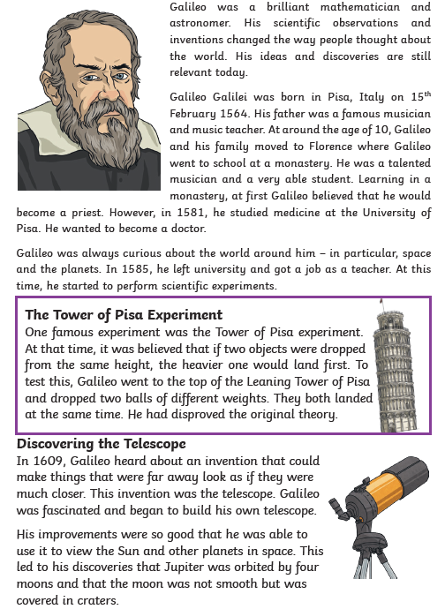
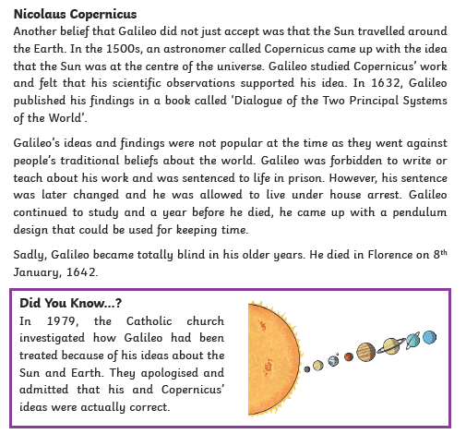

Y5 English Homework week 3 (23.1.25)
Question Sheet – only stick this sheet into your Homework book.

Galileo Galilei

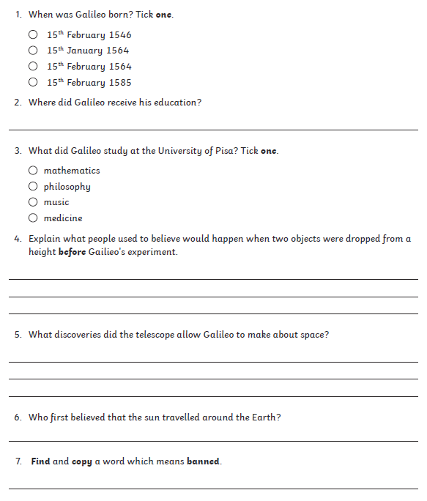
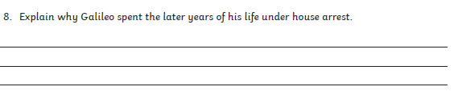

Y5 English Homework week 3 (23.1.25)
ANSWERS



