Y5 Maths Homework week 3 (23.1.25)

Mental and written multiplication and division strategies.

Please read the worked example to support you with questions 1 and 2.

Worked Example
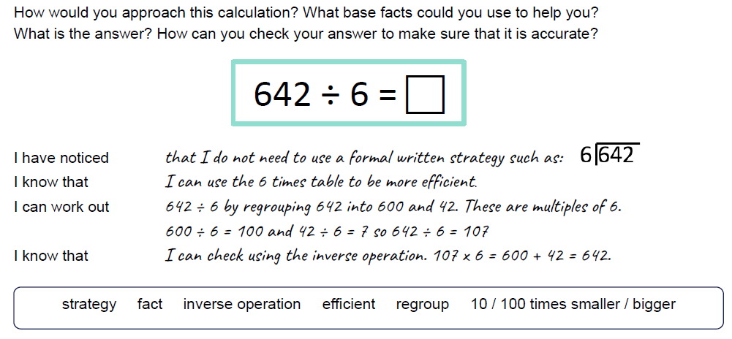

______________________________________________________________________________

Question 1:
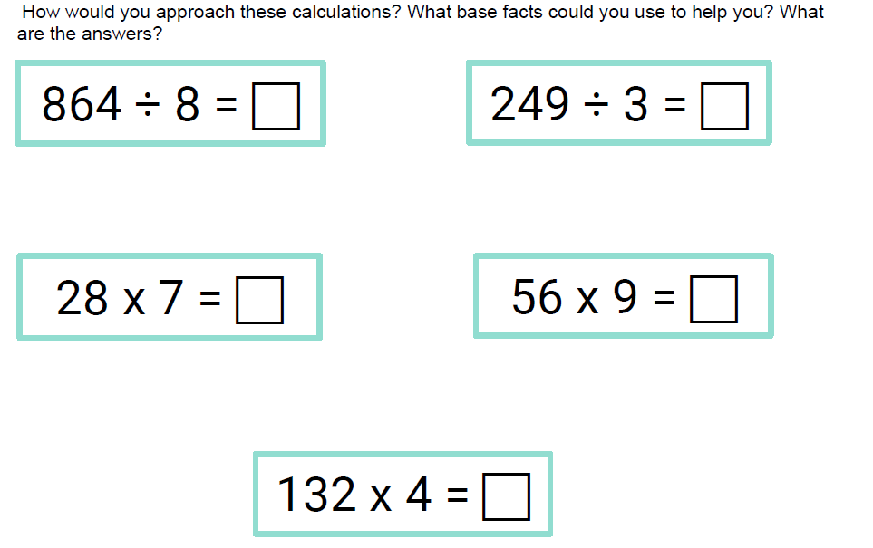

Question 2.

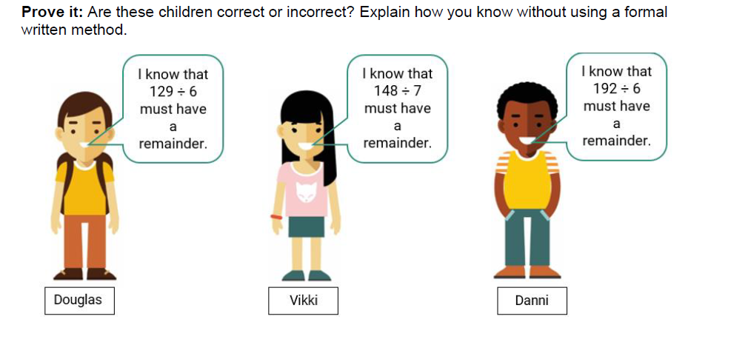

Stick these sheets in your Homework book then mark them by using the answer sheet in the Year 5 class page on the school website.

Y5 Maths Homework week 1 (23.1.25)

Mental and written multiplication and division strategies. ANSWERS

1.
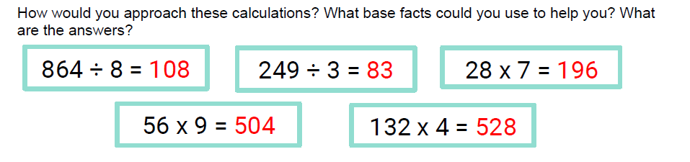

2.


