Y5 English Homework week 1 (9.1.25)
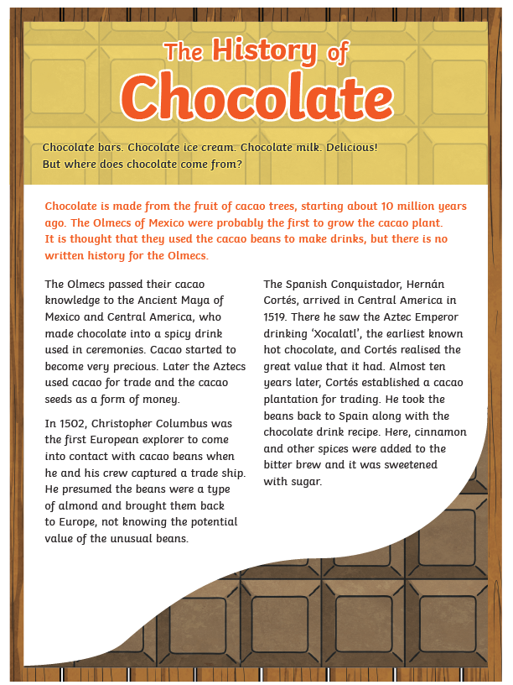

Page 2
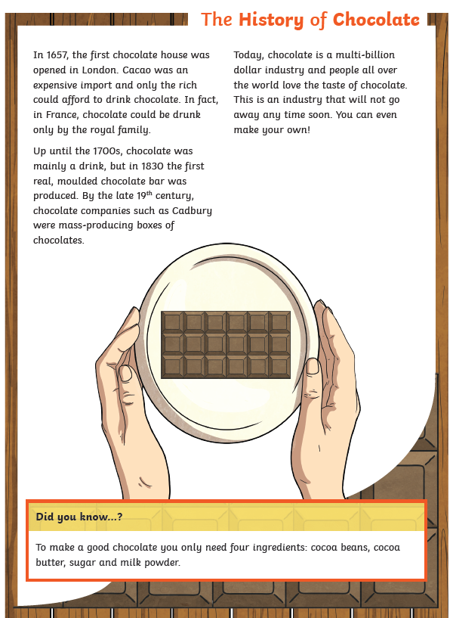
Y5 English Homework week 1 (9.1.25)
Question Sheet – only stick this sheet into your Homework book.

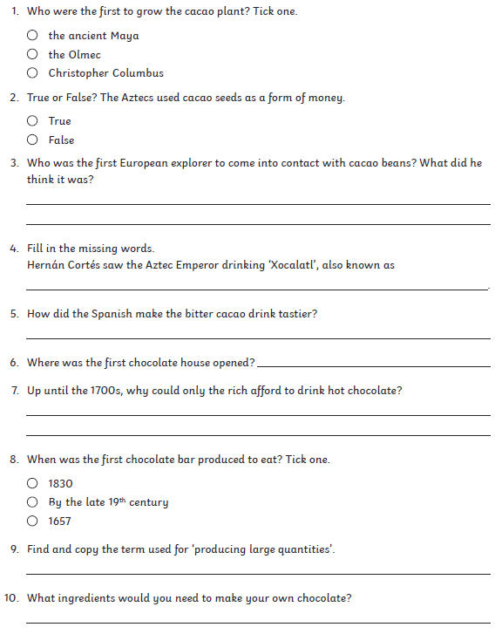
Y5 English Homework week 1 (9.1.25)
ANSWERS



