Y5 Maths Homework week 1 (9.1.25)

Prime Numbers and properties of other numbers.

Please read the worked example to support you with questions 1 and 2.

Worked Example:

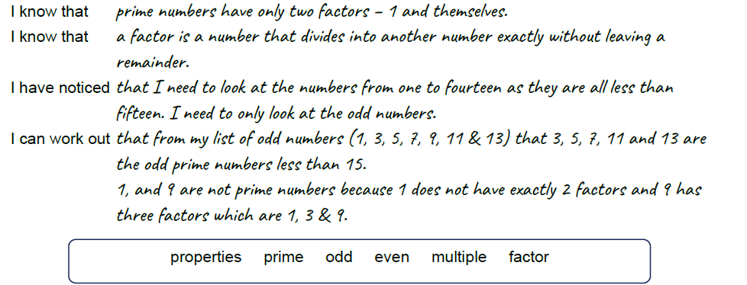
____________________________________________________________________________

Question 1.
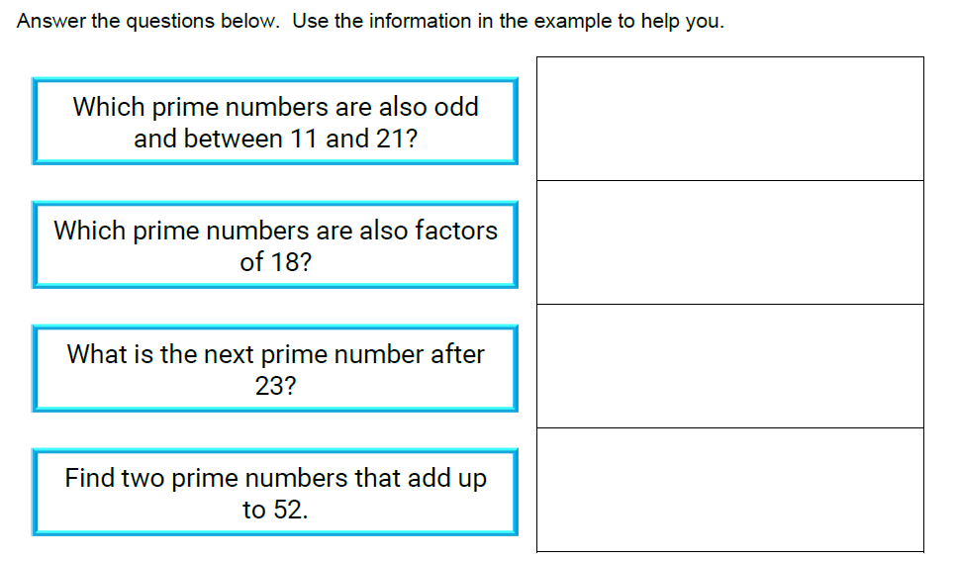

Question 2.

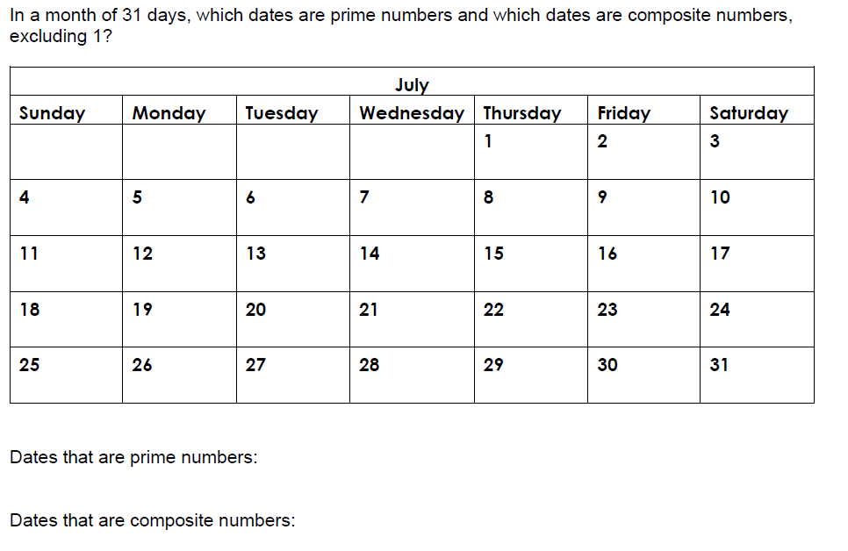

Stick these sheets in your Homework book then mark them by using the answer sheet in the Year 5 class page on the school website.

Y5 Maths Homework week 1 (9.1.25)

Prime Numbers and properties of other numbers. ANSWERS

1.
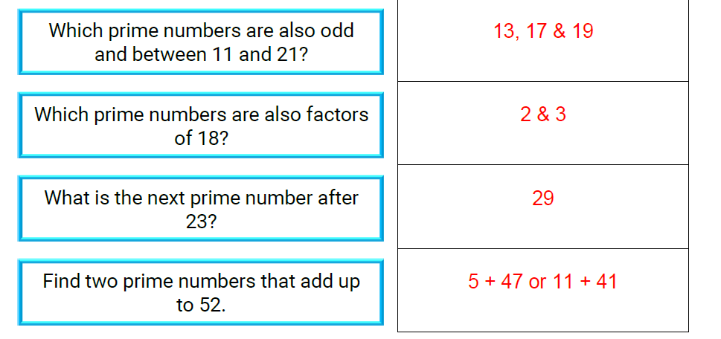

2.


