Homework Week 7
Year 5 Thursday 18th December
Dear Parents,

Reading
Please remember to read with your child over the holiday. Please sign and date the reading record. If you have any comments you wish to write about your child’s reading please do.

Maths
Go on TimeTable Rockstars or Hit the Button to help you keep your speed up on your times tables!

Over the holiday please remember:
- Check your pencil case for glues and pencils and restock if necessary
- Please check your name in your uniform and PE kits.
Please enjoy your time with family and friends.
Thank you for your continued support in the Autumn Term.
Ms Rowntree

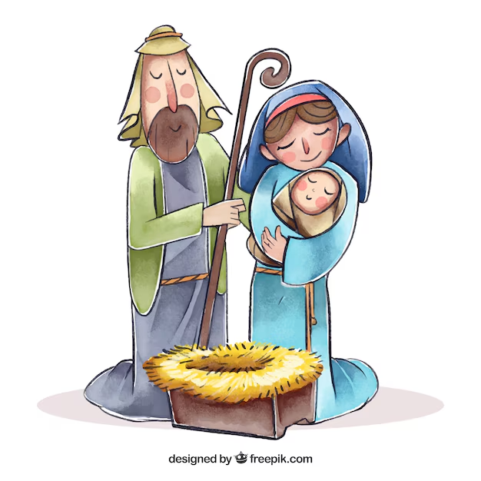

If you are looking for a book for your child - here is the recommended reading list
for Year 5.


