Homework Week 6
Year 5 Thursday 11th December
Dear Parents,
Please see below for homework this week.
Reading
Please remember to read with your child daily and support them with understanding through comprehension of the text and not just decoding. Please sign and date the reading record. If you have any comments you wish to write about your child’s reading please do.

Please remember:
- Check your pencil case for glues and pencils
- Reading Records to be in every day.
- Your PE Kit including trainers need to be in school everyday.
- Please remember to put your name in your uniform and PE kits.

Thank you for your continued support.
Ms Rowntree

Spellings
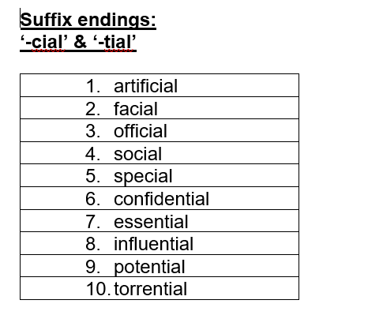

Maths – complete these addition and subtractions calculations.



