Homework Week 5
Year 5 Thursday 4th December
Dear Parents,
Please see below for homework this week.
Reading
Please remember to read with your child daily and support them with understanding through comprehension of the text and not just decoding. Please sign and date the reading record. If you have any comments you wish to write about your child’s reading please do.

Please remember:
- Check your pencil case for glues and pencils
- Reading Records to be in every day.
- Your PE Kit including trainers need to be in school everyday.
- Please remember to put your name in your uniform and PE kits.

Thank you for your continued support.
Ms Rowntree

Maths – complete these addition and subtractions calculations.

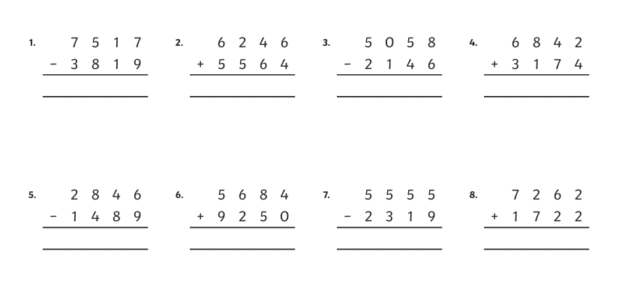

English - Revision of apostrophes for possession.
Change the sentences below so that they each contain an apostrophe to show possession by a singular noun. For example:
The rays belonging to the sun shone on the ground.
The sun’s rays shone on the ground.

- The reindeer belonging to Santa flew through the air.
- The harp belonging to the giant sang beautifully.
- The cauldron belonging to the witch boiled and bubbled.
- The tail belonging to the dog wagged.
- The wheel belonging to the car had a puncture.
- The toys belonging to the child were scattered on the floor.
- The dress belonging to Molly hung in the wardrobe.
- The phone belonging to Cameron began to ring.

Write your answers in your Homework book.

