Homework Week 4
Year 5 Thursday 27th November
Dear Parents,
Please see below for homework this week.
Reading
Please remember to read with your child daily and support them with understanding through comprehension of the text and not just decoding. Please sign and date the reading record. If you have any comments you wish to write about your child’s reading please do.
English
Please complete the comprehension on Neil Armstrong. Only stick your answers in and mark your work. Plus the work on subordinating conjunctions.
Here is a reminder of subordinating conjunctions:
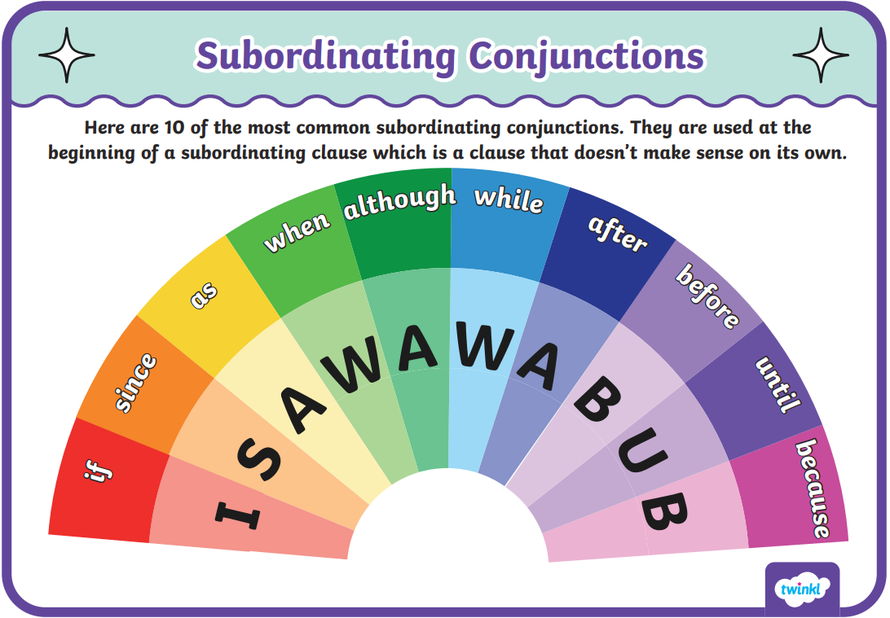

Please remember:
- Check your pencil case for glues and pencils
- Reading Records to be in every day.
- Your PE Kit including trainers need to be in school everyday.
- Please remember to put your name in your uniform and PE kits.

Thank you for your continued support.
Ms Rowntree
Maths: Our Maths homework this week.



