Homework Week 2
Year 5 Thursday 15th January
Dear Parents,
Reading
Please remember to read with your child. Please sign and date the reading record. If you have any comments you wish to write about your child’s reading please do.

English:
Our English task this week is to write a review of a book that you read and enjoyed over the Christmas holidays. You can use the template provided or design your own book review layout.

Maths:
Our Maths homework this week is to multiply two numbers together,
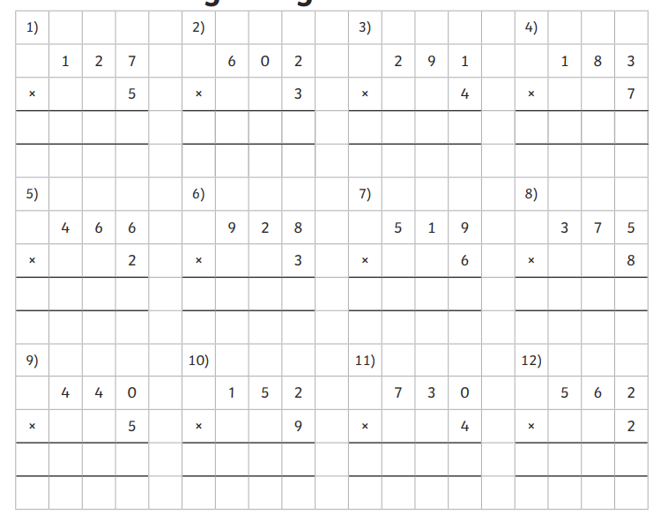

Please remember:
- Check your pencil case for glues and pencils and restock if necessary
- Please check your name in your uniform and PE kits
- Our PE days are Monday and Friday so please make sure your kit is in school
Thank you for your continued support.
Ms Rowntree

