Y5 Maths Homework Week 1

Prime Numbers and properties of other numbers.

Please read the worked example to support you with questions 1 and 2.

Worked Example:
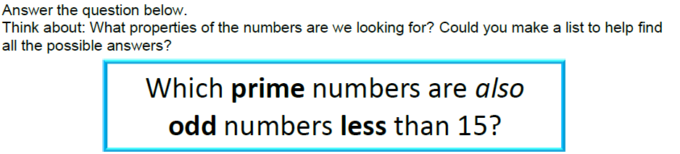
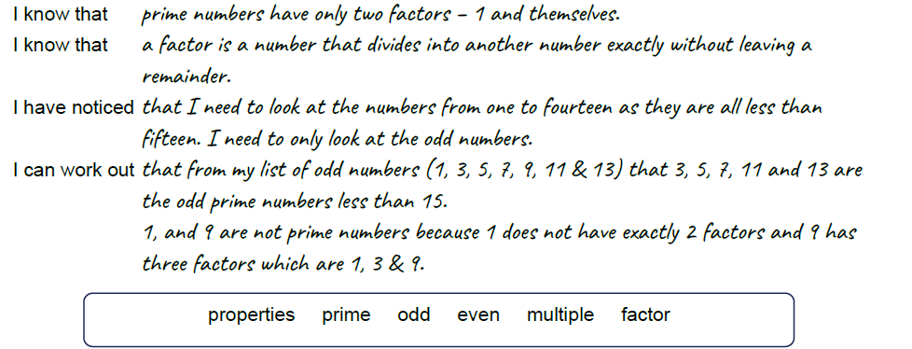
____________________________________________________________________________

Question 1.
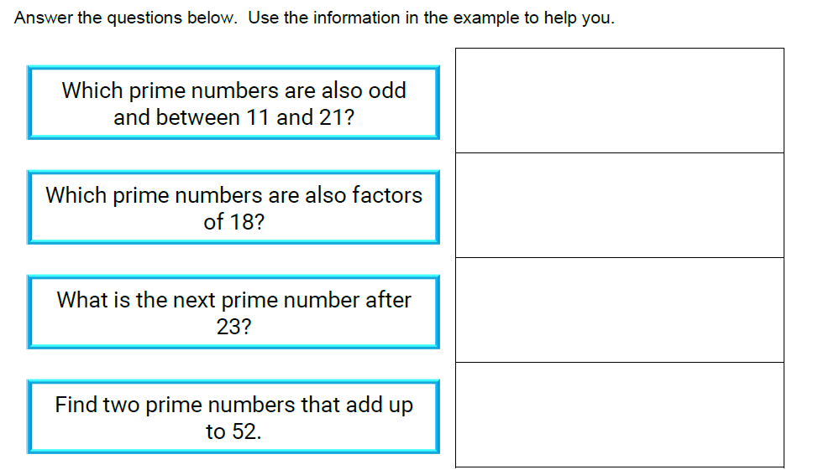

Question 2.

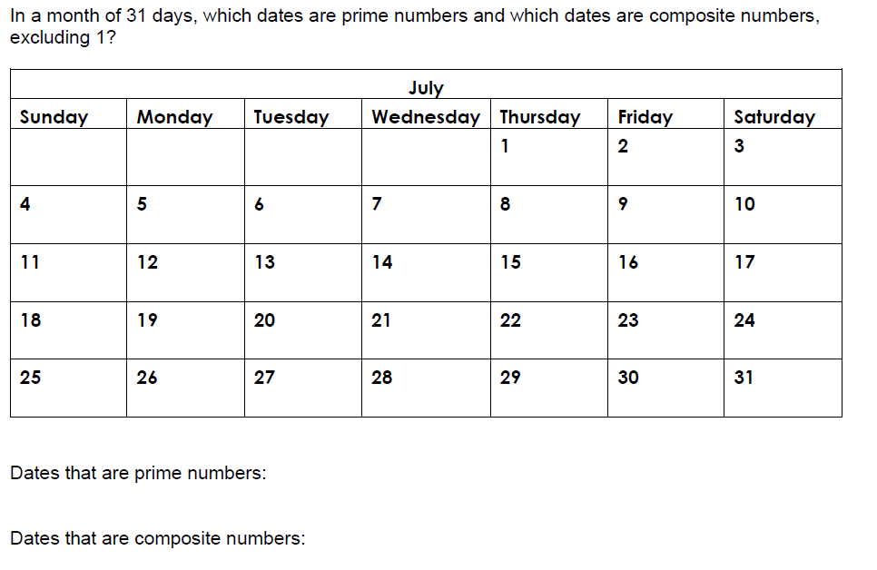

Prime Numbers and properties of other numbers. ANSWERS

1.
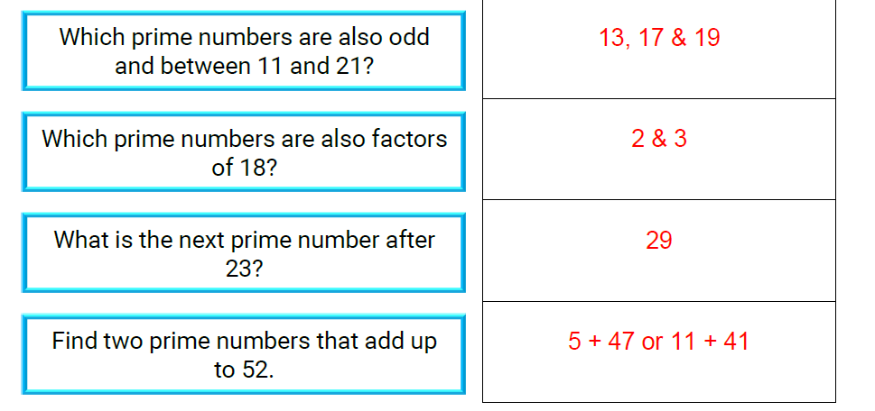

2.


