Homework Week 4
Year 5 Thursday 29th January
Dear Parents,
Reading
Please remember to read with your child. Please sign and date the reading record. If you have any comments you wish to write about your child’s reading please do.

Racial Justice Sunday
The Catholic Church is called universal because it belongs to people all over the world. Saints come from many different countries, cultures, and backgrounds, showing us that anyone can follow Jesus and live a holy life.
The Bible reminds us, “Whoever loves God must also love his brother and sister” (1 John 4:21), and the saints lived this out by caring for others and being faith filled and brave. Even though they were all different, they shared a love for God and for people, reminding us that we are one family and that everyone is called to live with faith, courage, and love.
The theme this year is “Whoever loves God must also love his brother and sister”

This year we will be focusing on different Saints who have lived by this theme and in Year 5 we are researching St Augustine Zhao Rong.

Tasks:
- Homework: write the following phrase in your home language, on the template provided below and decorate it.
“Whoever loves God must also love his brother and sister”

- Homework – Please research some facts about St Augustine Zhao Rong and write about him on the sheet provided. You can also write how you can be like this saint in your everyday life.
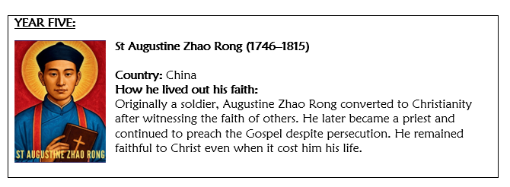

Maths:
Our Maths homework this week is to practice your times tables. You can do this on Times Table Rockstars or Hit the Button.
Please remember:
- Check your pencil case for glues and pencils and restock if necessary
- Please check your name in your uniform and PE kits
Thank you for your continued support.
Ms Rowntree



