Y5 English Homework week 3

Galileo Galilei
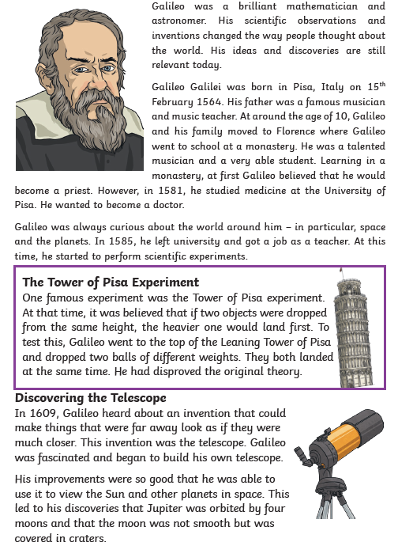
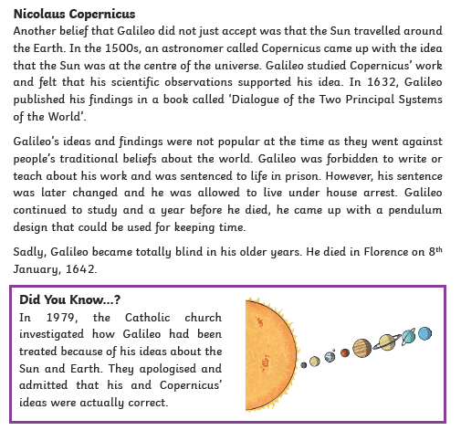

Y5 English Homework week 3
Question Sheet – only stick this sheet into your Homework book.

Galileo Galilei

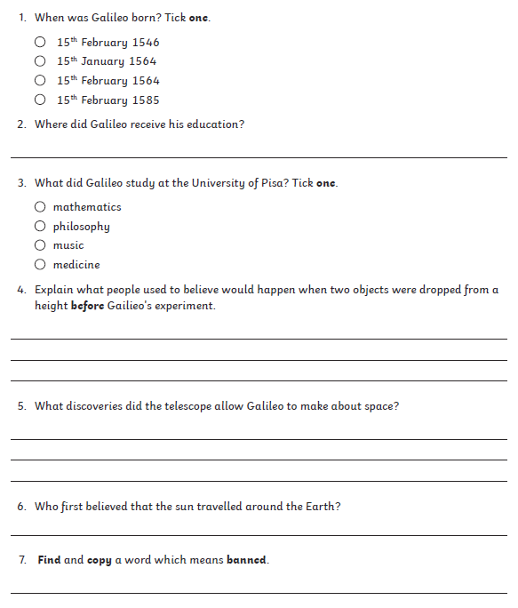
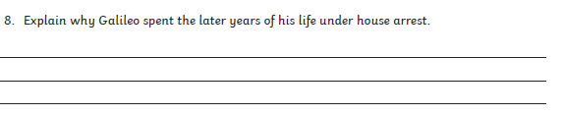

Y5 English Homework week 3
ANSWERS



