Year 5 Maths Homework

Choose the activity you would like to do (or you can do both). Make sure that you stick the sheet into your homework book and check the answers.

Activity 1: 2-Digit x 2-Digit Multiplication

1). 2).
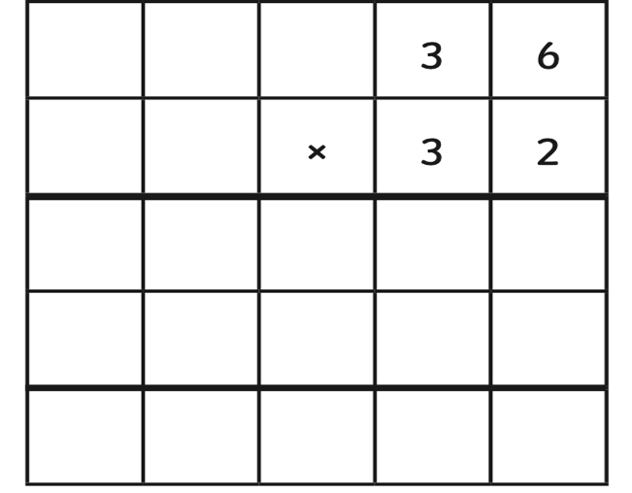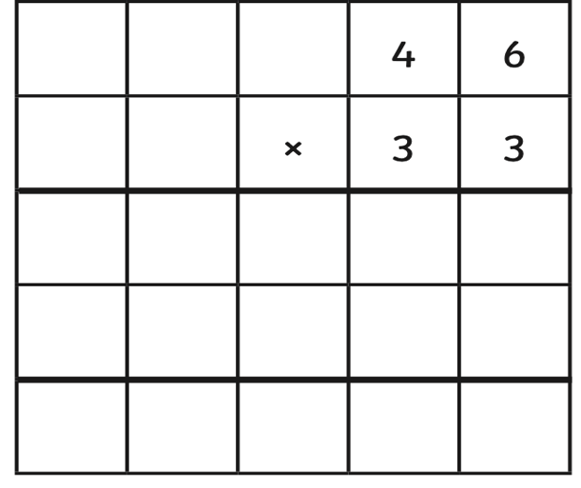

3). 4).
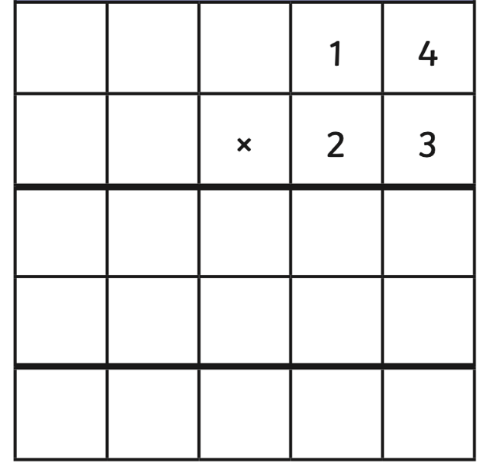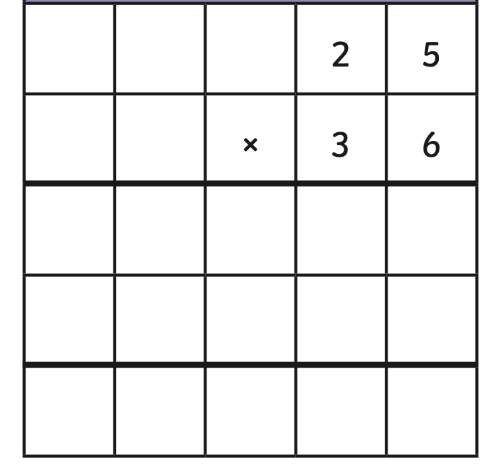

5). 6).

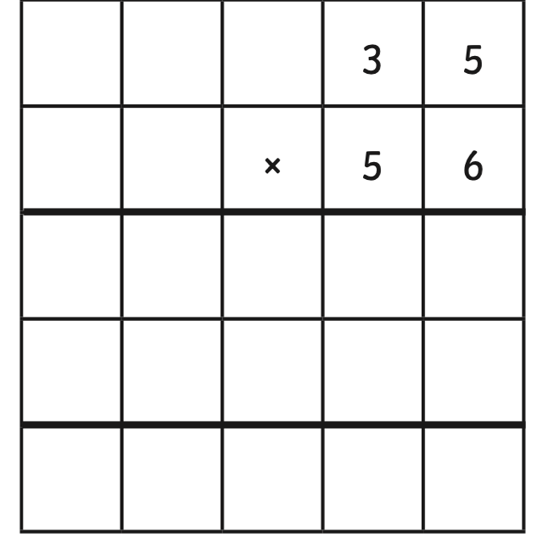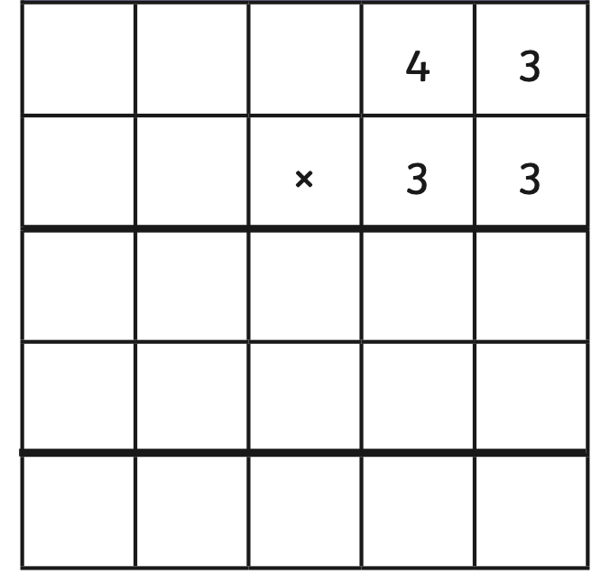

Activity 2: 3-Digit x 2-Digit Multiplication

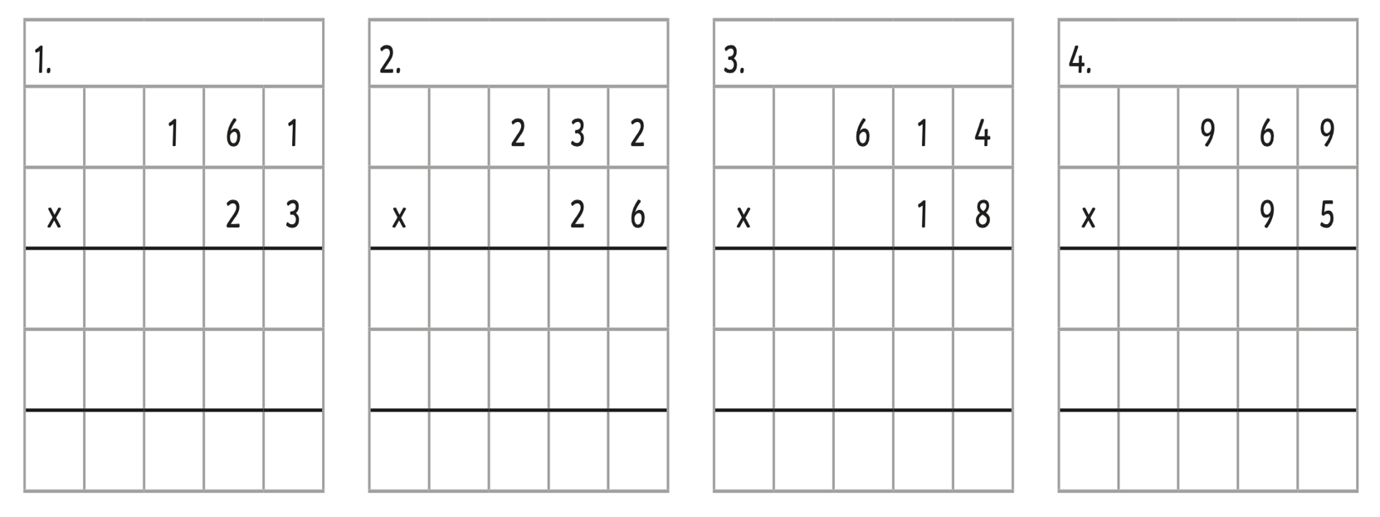

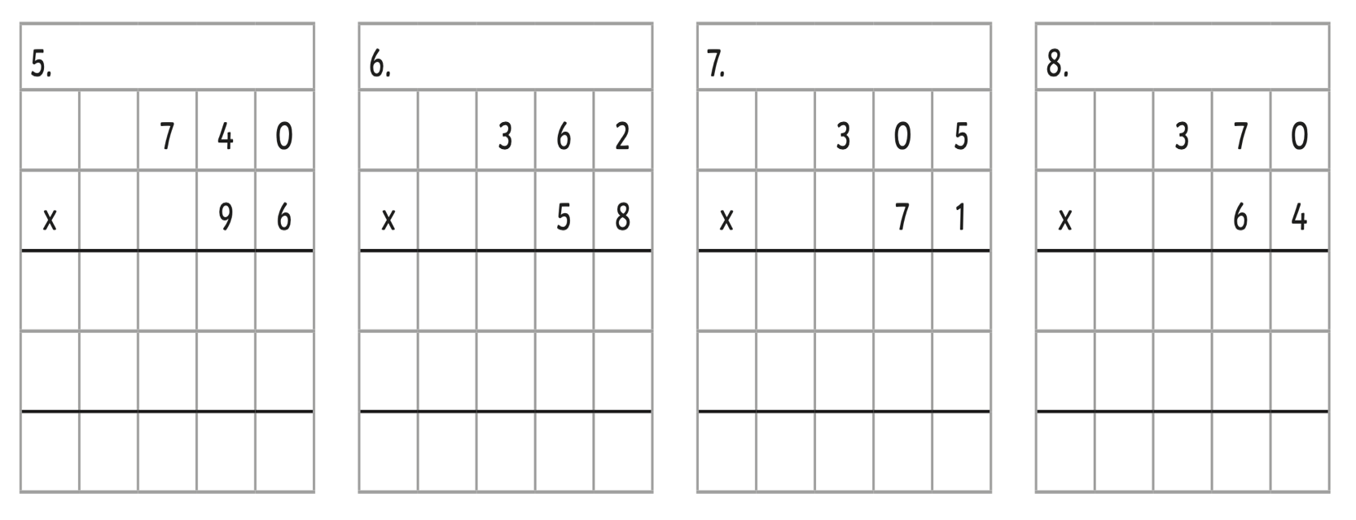

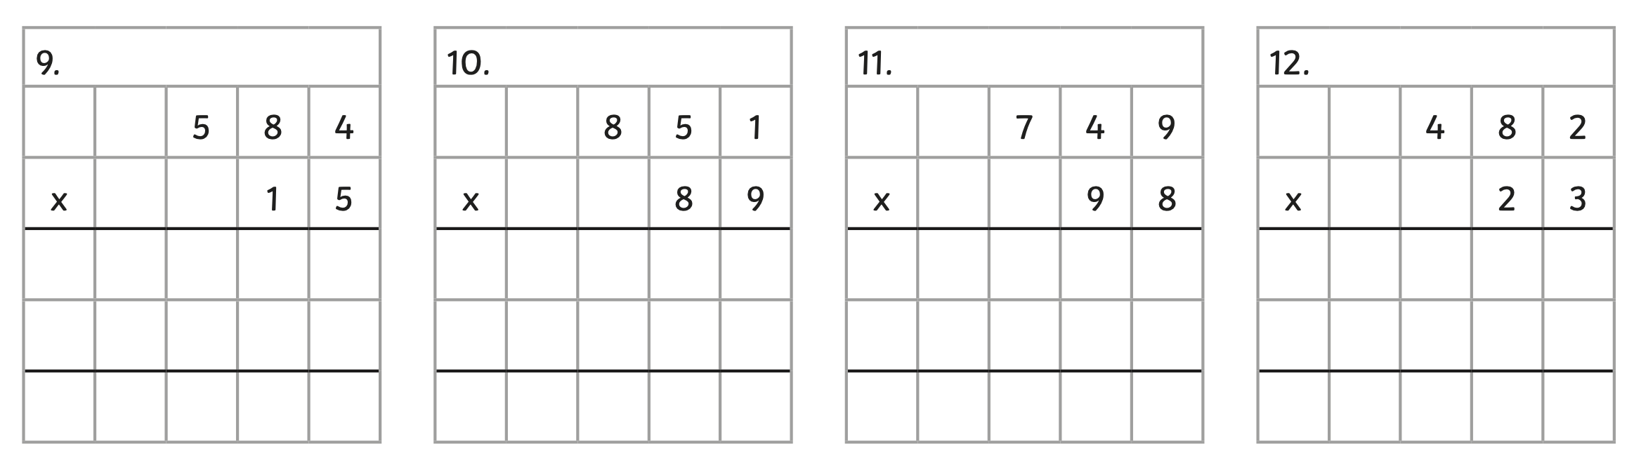

Year 5 Maths Homework ANSWERS

Activity 1: 2-Digit x 2-Digit Multiplication - Answers

1). 2).
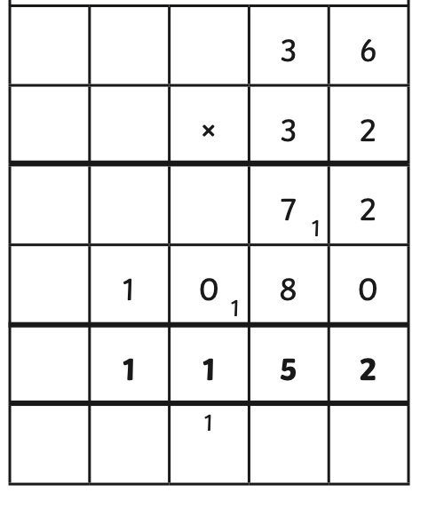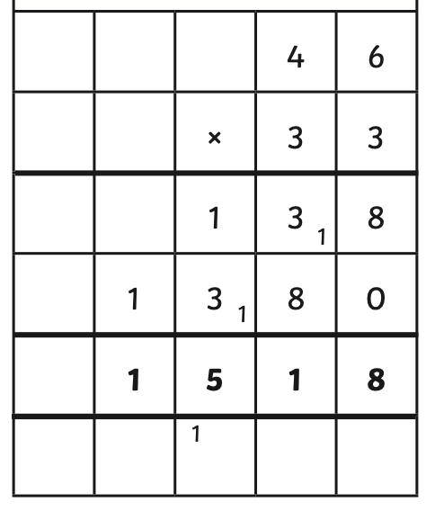
3). 4).
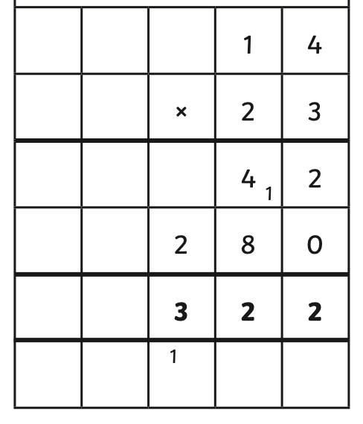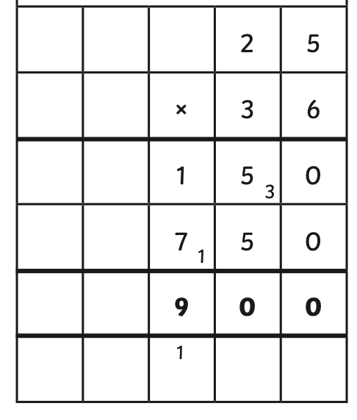

5). 6).
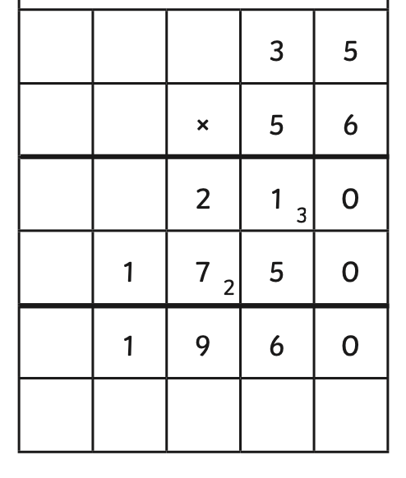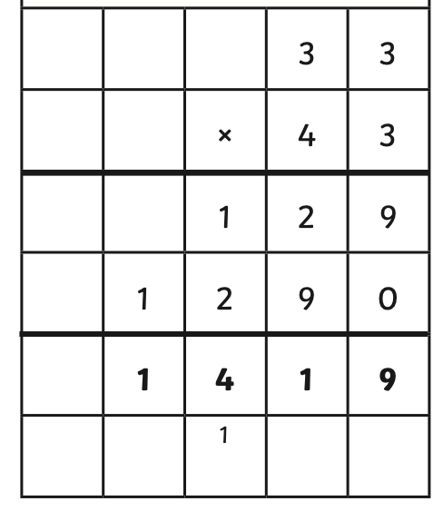

Activity 2: 3-Digit x 2-Digit Multiplication Answers



