English Homework Week 4

A relative clause is a specific type of subordinate clause that adapts, describes or modifies a noun. Relative clauses add information to sentences by using a relative pronoun such as who, that or which.

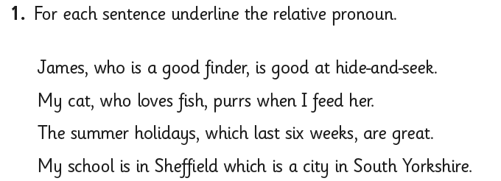

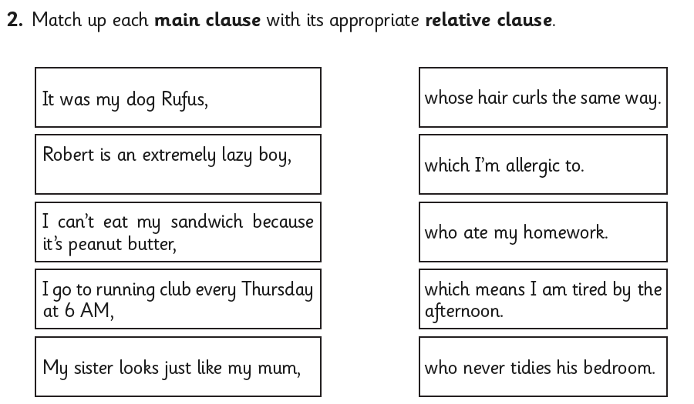

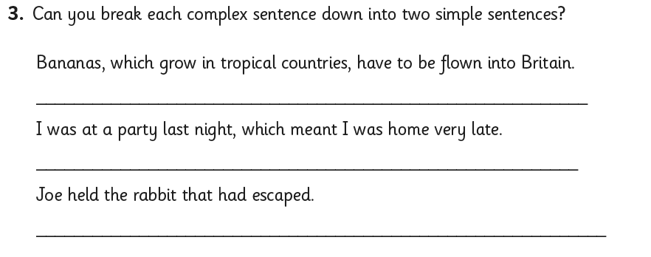

English Homework Week 4
ANSWERS



