Y5 Maths Homework week 5

Choose the activity you would like to do (or you can do both). The remainders just need to be simple remainders, not fractions or decimals. Make sure that you stick the sheet into your homework book.

Activity 1: short division practise with remainders.

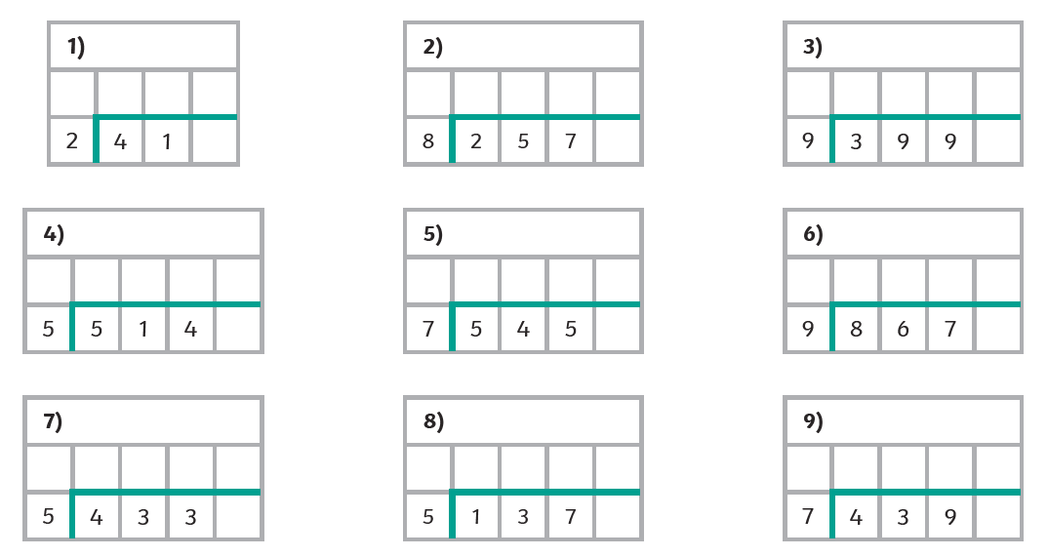

Activity 2: short division practise with remainders.

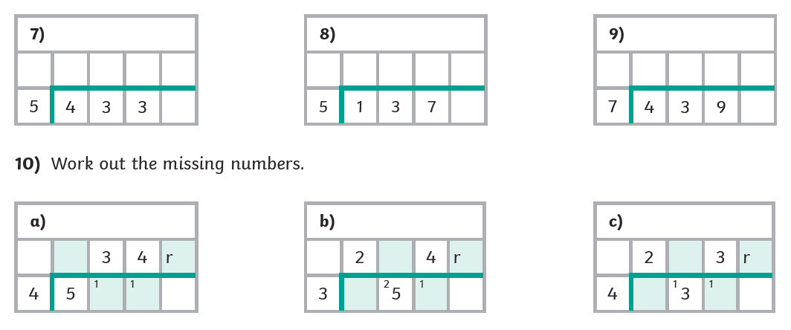

Year 5 Maths Homework ANSWERS

Activity 1: Short division practise with remainders - Answers

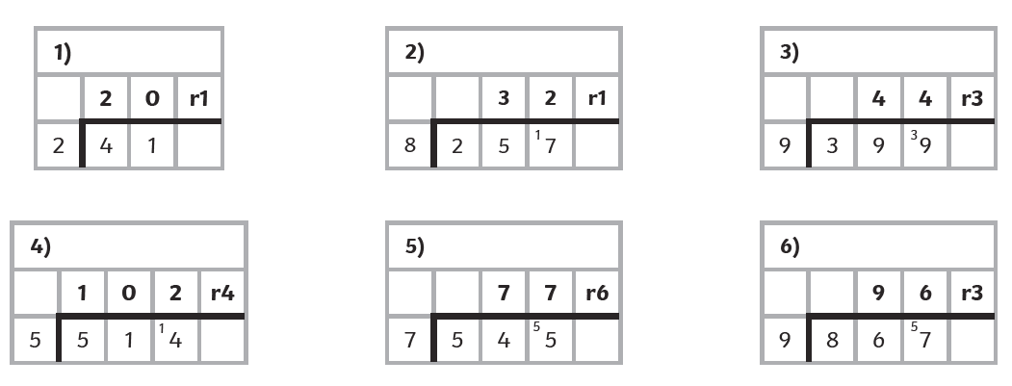

Activity 2: Short division practise with remainders – Answers



