Year 5 English Homework

All of the punctuation has been removed from the extract below:

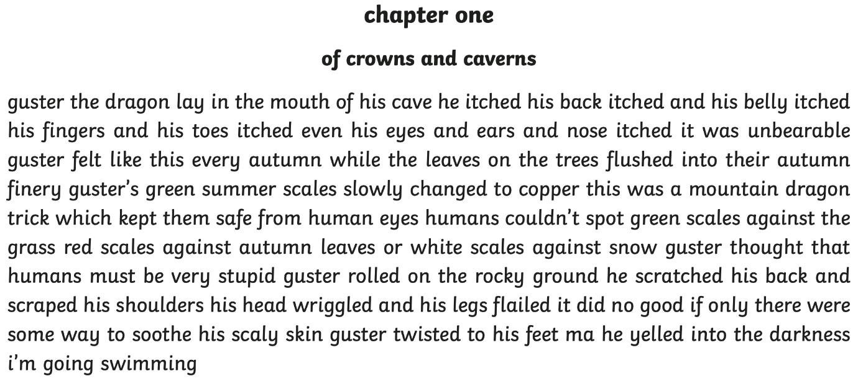

Rewrite the extract with the full stops and capital letters where they should be in your Homework book. Don’t forget to add paragraph breaks too!

Answer sheet.



