Homework Week 3
Year 5 Thursday 25th September

Dear Parents,
Please see below for homework this week.
Reading
Please remember to read with your child daily and support them with understanding through comprehension of the text and not just decoding. Please sign and date the reading record. If you have any comments you wish to write about your child’s reading please do so.
Spellings: Spellings are tested on Tuesdays and the new spelling pattern/rule introduced for that week. This week we are revising commonly used and misspelt words.

Revision of plural rules

- amateurs
- environments
- muscles
- cargoes
- potatoes
- addresses
- harasses
- halves
- wolves
- beliefs

English: Our English task this week is on Subordination conjunctions. Please see the separate sheet, and once complete mark your work from the answer sheet provided.

Our Project – History – The Vikings
In History we are studying the Vikings, please create something based on this. It could be a 3D model of a Viking long boat or a Viking helmet, or it could be an information booklet, or a power point. The choice is yours. Please hand in your project during the week beginning 20th October. This will be put on our display for all to see.

Maths: Our Maths homework this week is on Place value.
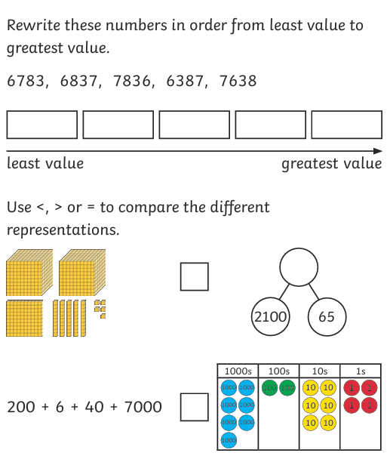

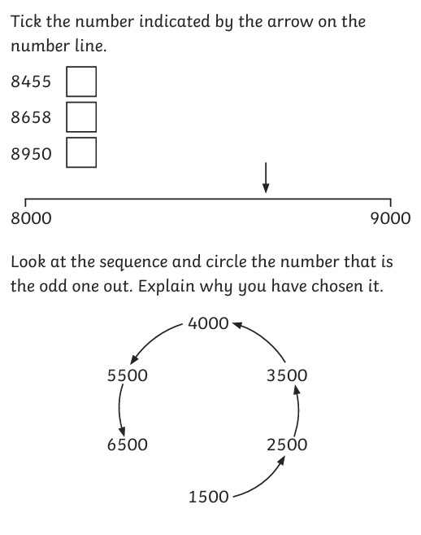

Please remember:
- Reading Records to be in every day.
- Your PE Kit including trainers need to be in school everyday.
- Please remember to put your name in your uniform and PE kits.

Thank you for your continued support.
Ms Rowntree

