Y5 English Homework week 3
Please stick this answer sheet into your Homework book and then mark your work.

Subordinating Conjunctions

Underline the subordinating conjunction in each sentence.

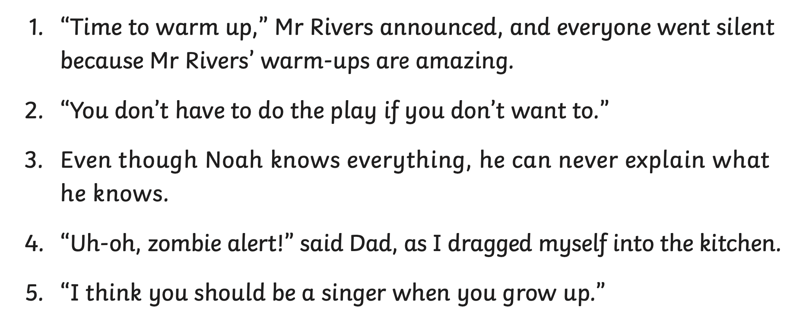

Y5 English Homework week 3
ANSWERS

Subordinating Conjunctions

Underline the subordinating conjunction in each sentence.


