Year 5 English Homework (Autumn Week 2. 9.9.24)

All of the punctuation has been removed from the extract below:

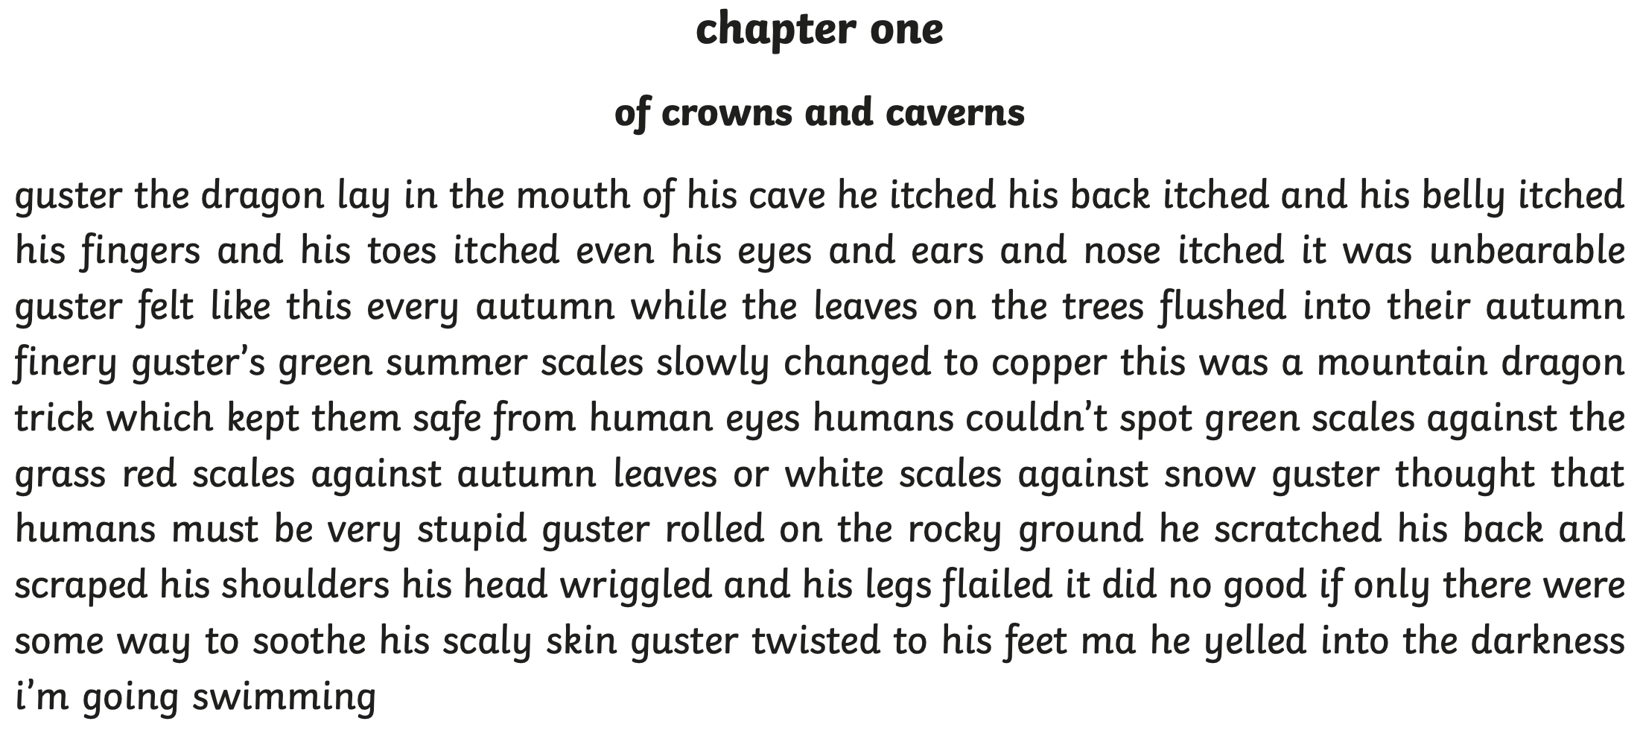

Rewrite the extract with the full stops and capital letters where they should be in your Homework book. Don’t forget to add paragraph breaks too!

Then mark your work using the answer sheet which is on the Year 5 class page in the Homework section (week 2).

Year 5 English Homework (Autumn Week 2. 9.9.24)

Answer sheet.



