Year 5 Maths Homework (Autumn Week 2. 9.9.24)

Challenge 1

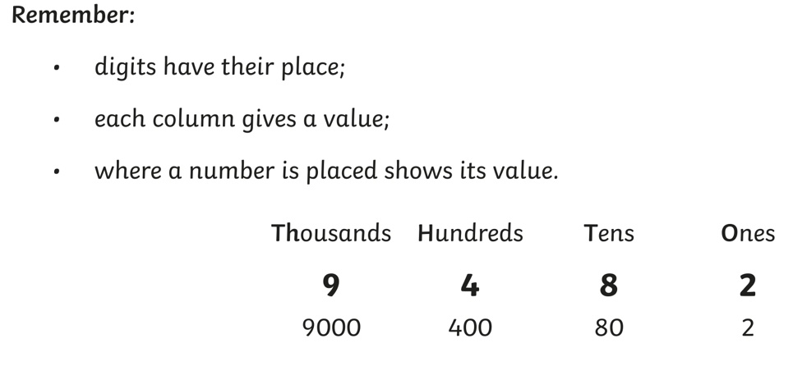

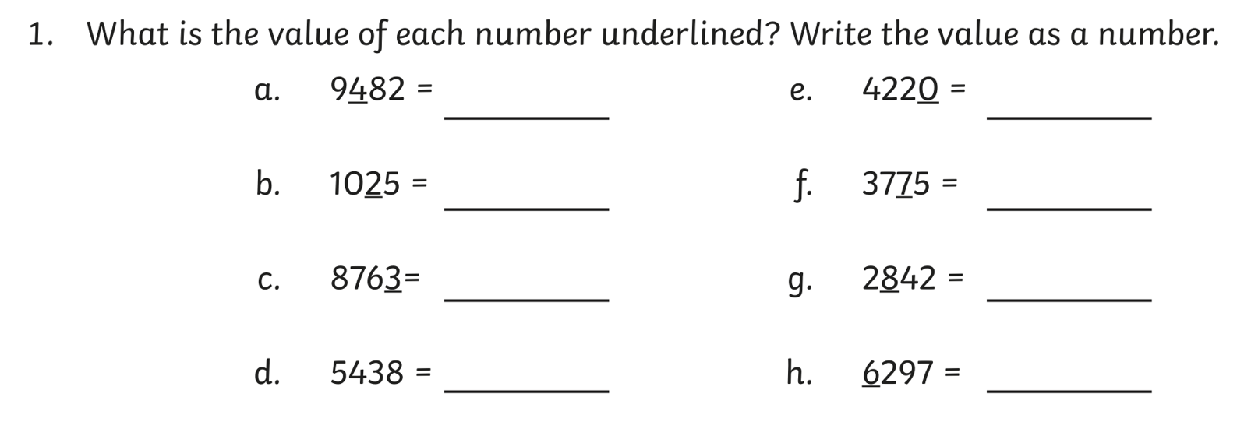

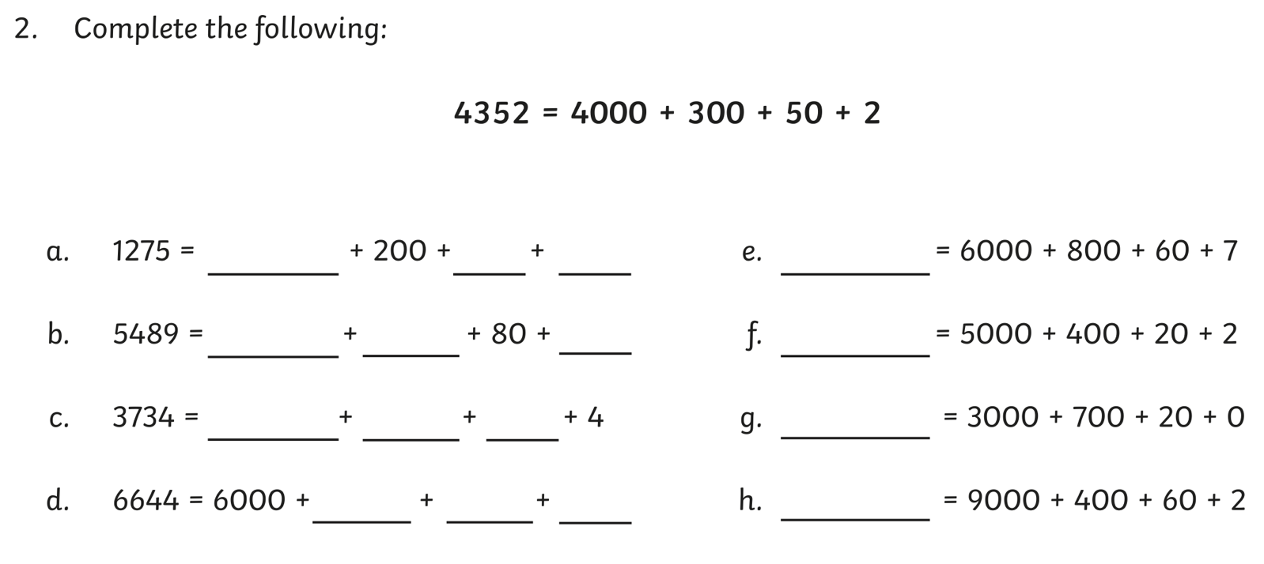

Year 5 Maths Homework (Autumn Week 2. 9.9.24)

Challenge 2

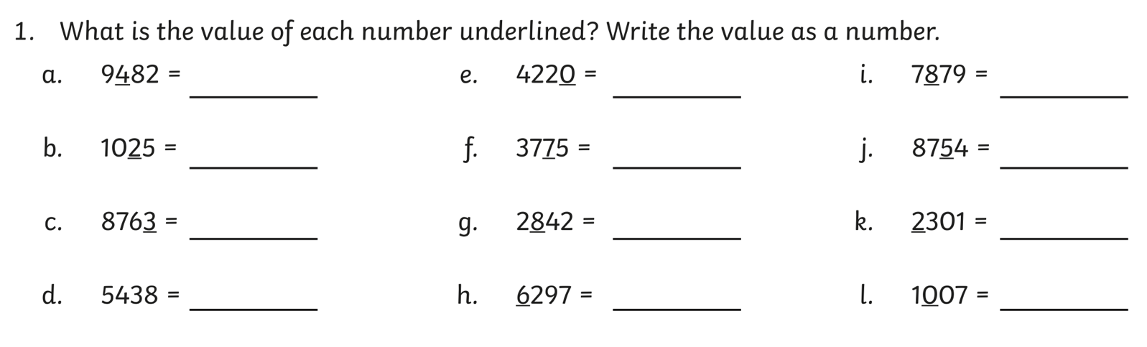

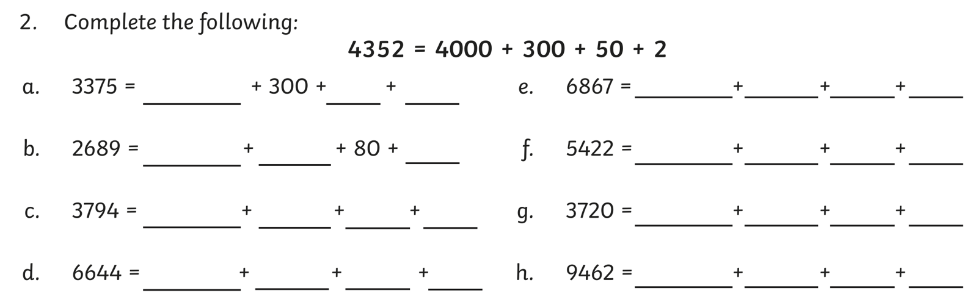

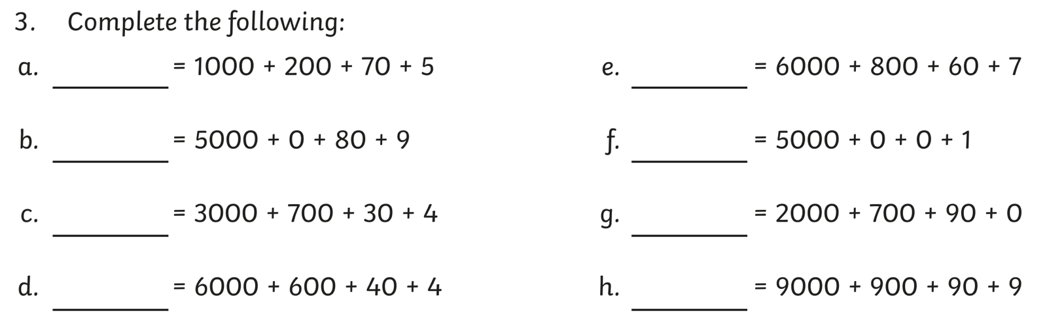

Year 5 Maths Homework (Autumn Week 2. 9.9.24)

Challenge 3

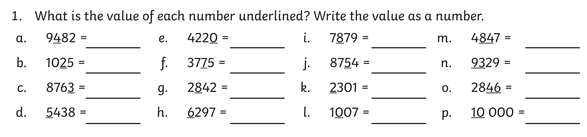

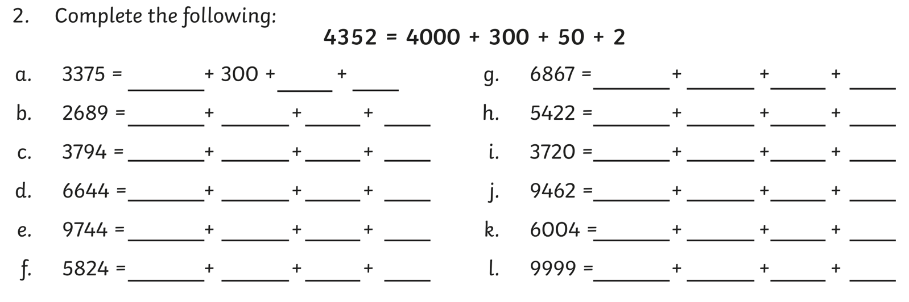

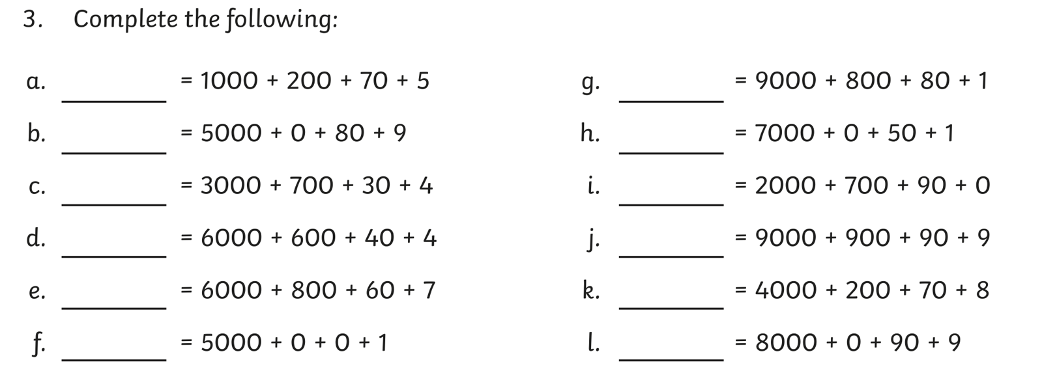

Year 5 Maths Homework (Autumn Week 2, 9.9.24). ANSWERS.

Challenge 1
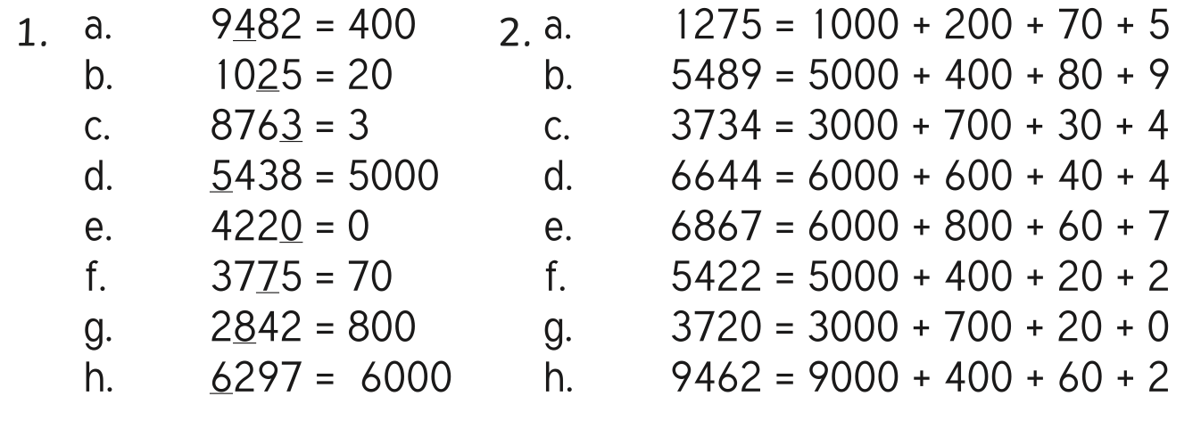

Challenge 2
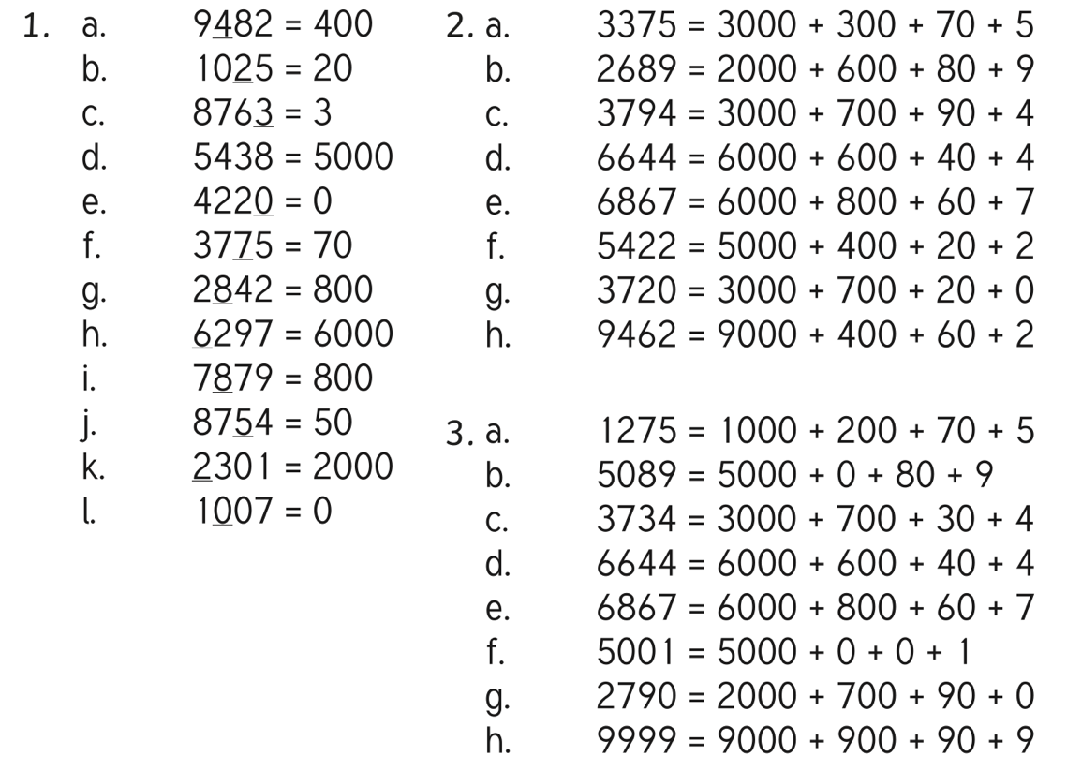
Challenge 3



