Y5 English Homework week 12 (28.11.24) Don’t stick this sheet in your Homework book.

Sir Isaac Newton
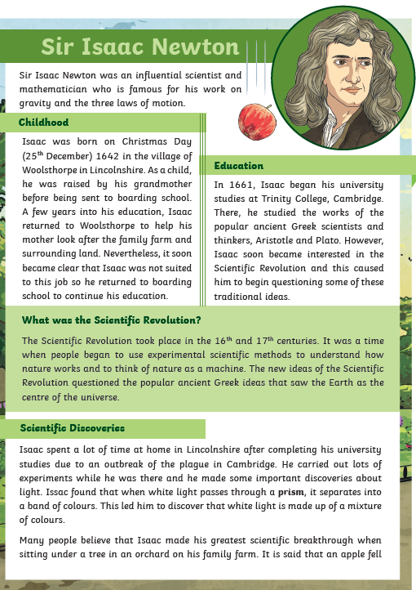

Page 2
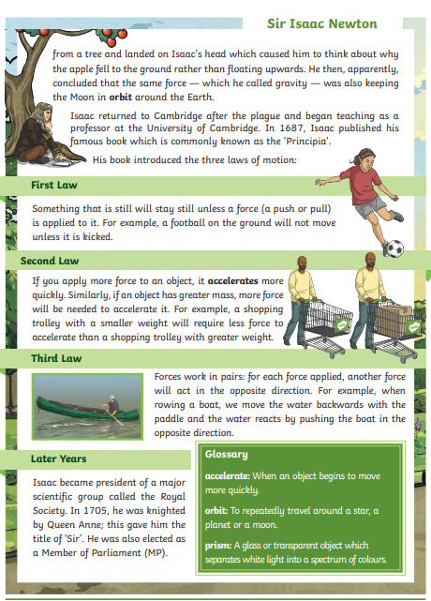

Y5 English Homework week 12 (28.11.24)
Question Sheet – only stick this sheet into your Homework book.
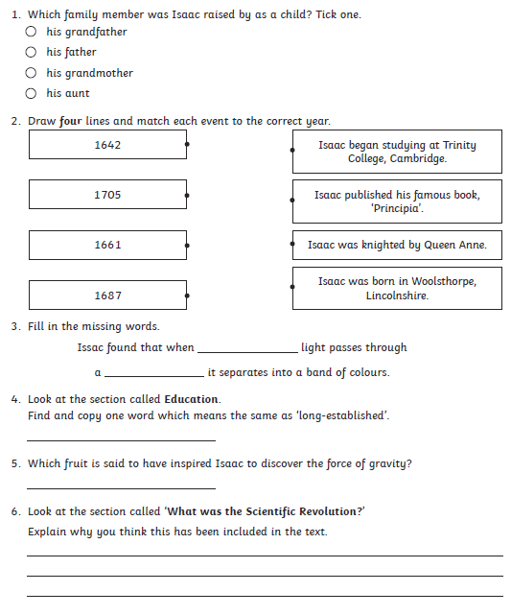
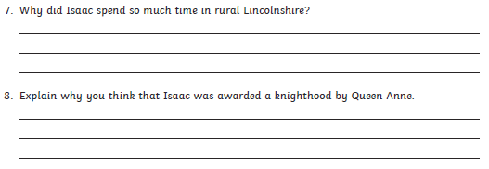

Y5 English Homework week 12 (28.11.24)
ANSWERS


