Y5 Maths Homework (28.11.24)
Please answer the questions 1 and 2 and stick this sheet in your Homework book.
There is an optional extra challenge (question 3) to complete if you would like to challenge
yourself. You will need to stick this sheet in your Homework book too.
Please mark your maths and make corrections using the answer sheet from the school website
(Class News – Year 5 – Homework – week 12).

All complete questions 1 and 2. Please stick in your Homework book.
1).
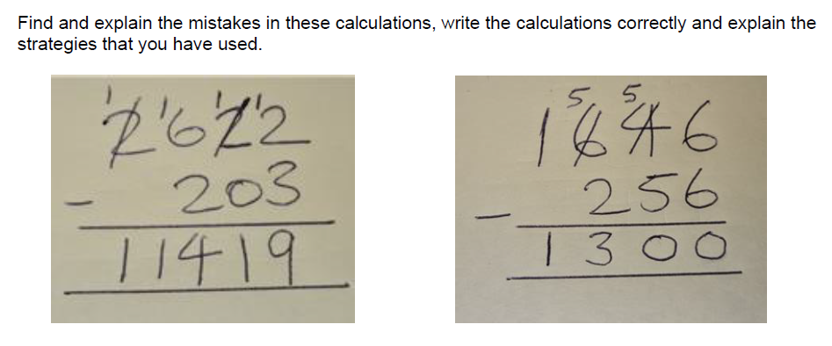

2.
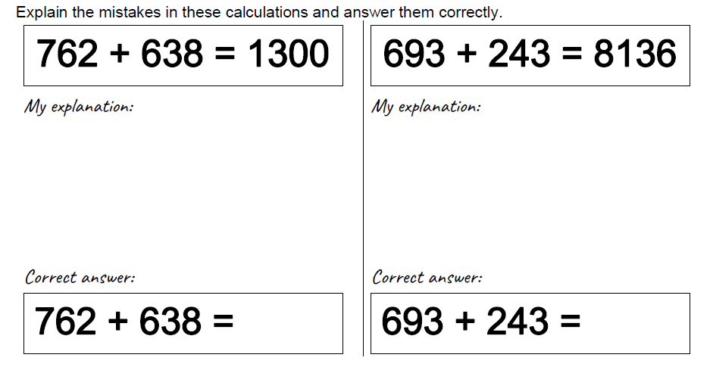
Now mark your work and make any corrections in green pen.

Y5 Maths Homework (28.11.24)
Optional extra challenge: please stick in your Homework book.
3).
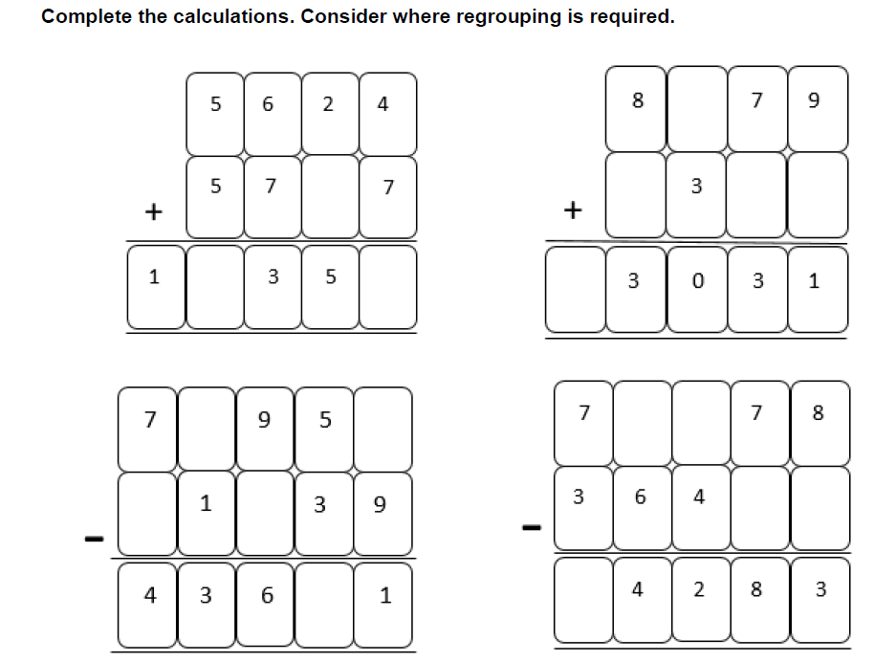

Now mark your work and make any corrections in green pen.

Y5 Maths Homework (28.11.24)
ANSWERS:
1.
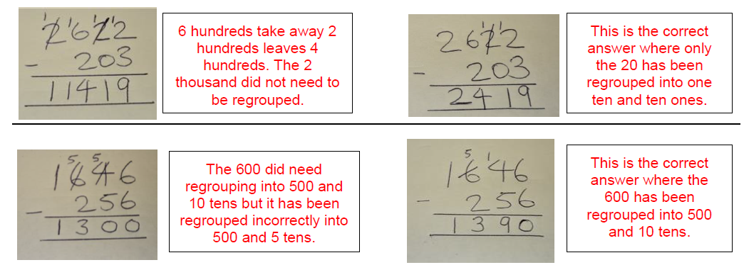
2.
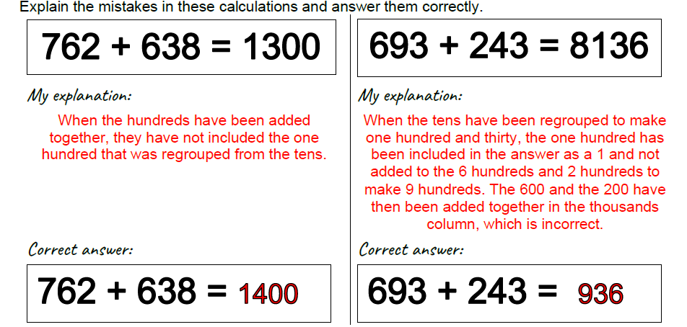
3. (Optional extra challenge).


