Y5 English Homework week 7 (17.10.24)

The Bermuda Triangle

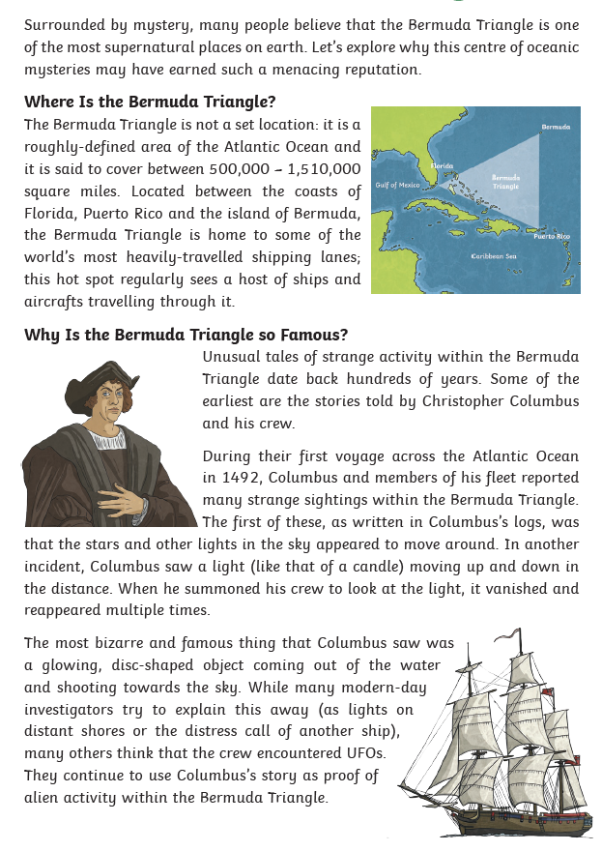

Page 2
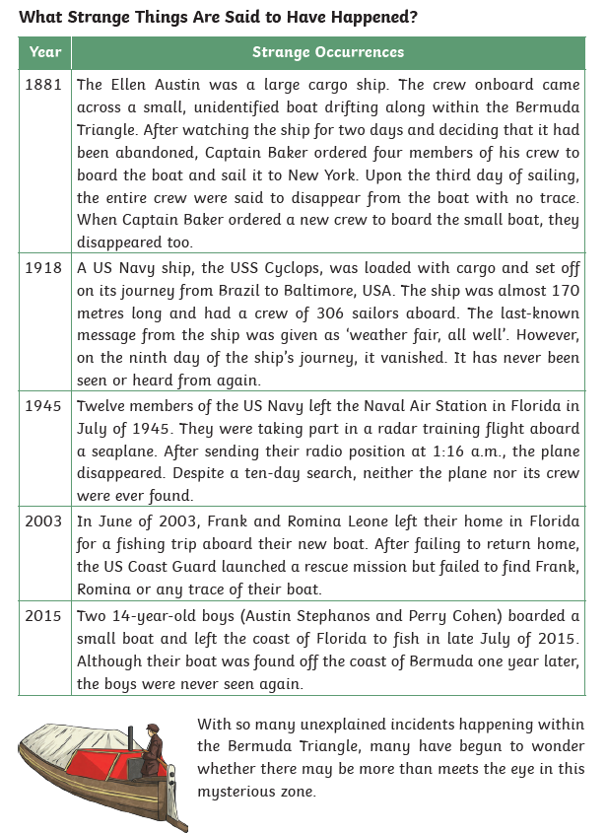

Y5 English Homework week 7 (17.10.24)
Question Sheet – only stick this sheet into your Homework book.

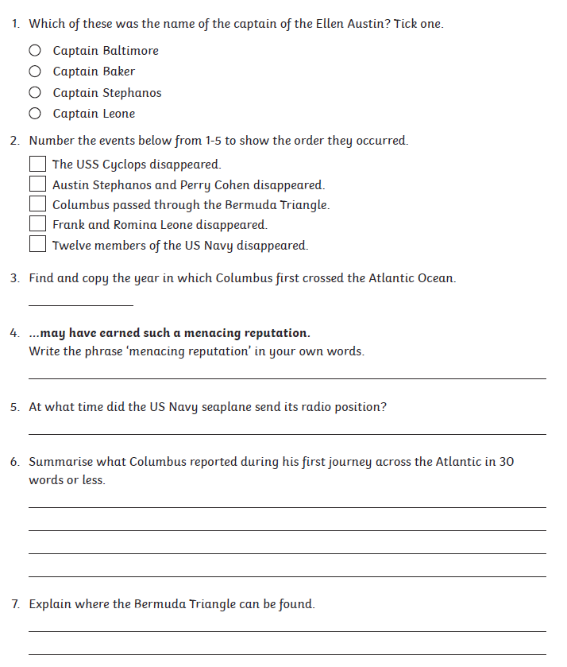

Y5 English Homework week 7 (17.10.24)
ANSWERS



