Y5 Maths Homework week 7 (17.10.24)

Choose between Challenge 1 or Challenge 2 (you can do both if you want). Complete the questions, stick the sheet in your Homework Book and then mark it. The answers are on the school website (Year 5 class page Autumn 1 homework week 7).

Challenge 1: Ordering and comparing decimals with up to 2 decimal places.

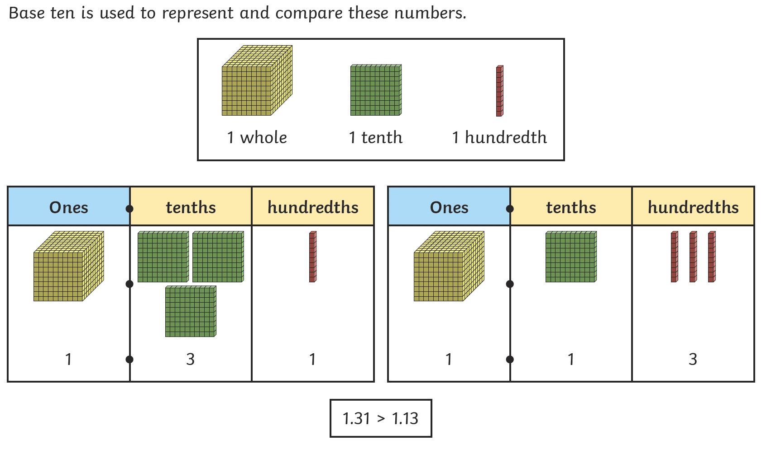
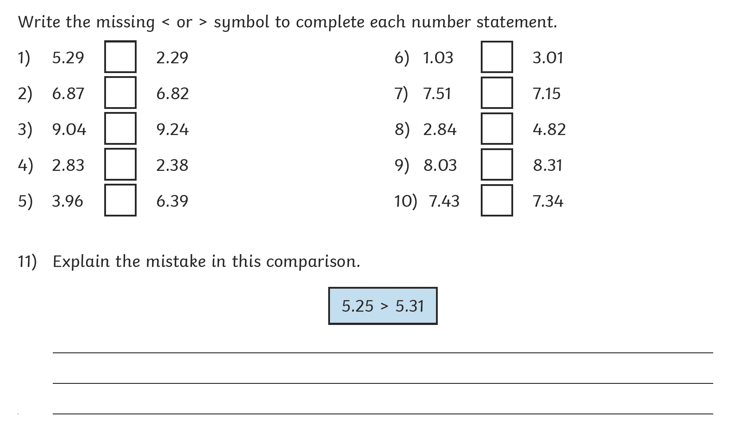

Challenge 2: Ordering and comparing decimals with up to 3 decimal places.

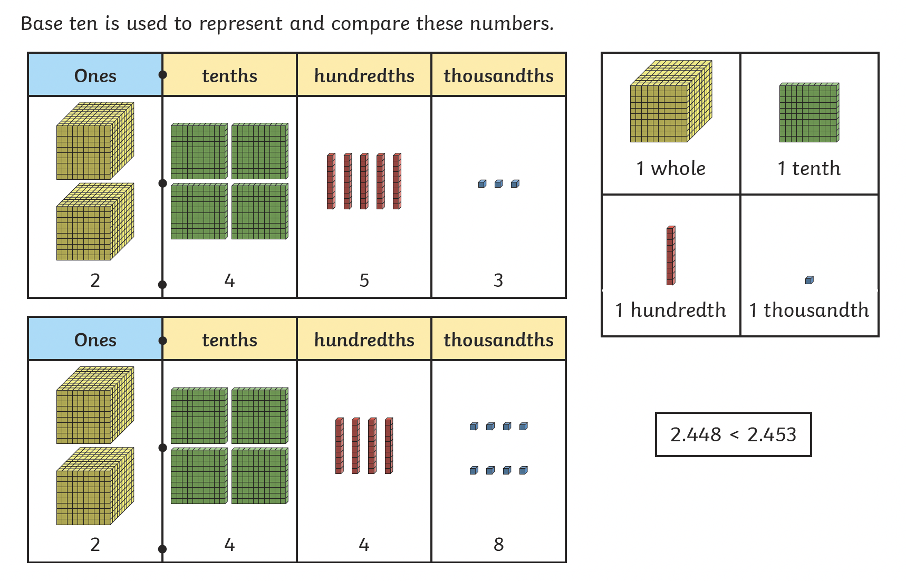
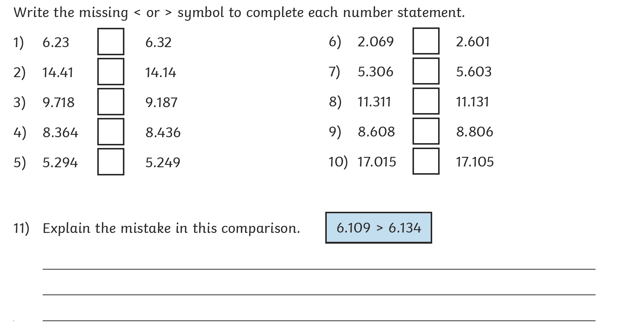

Y5 Maths Homework week 7 (17.10.24)

Challenge 1: Ordering and comparing decimals with up to 2 decimal places.
ANSWERS

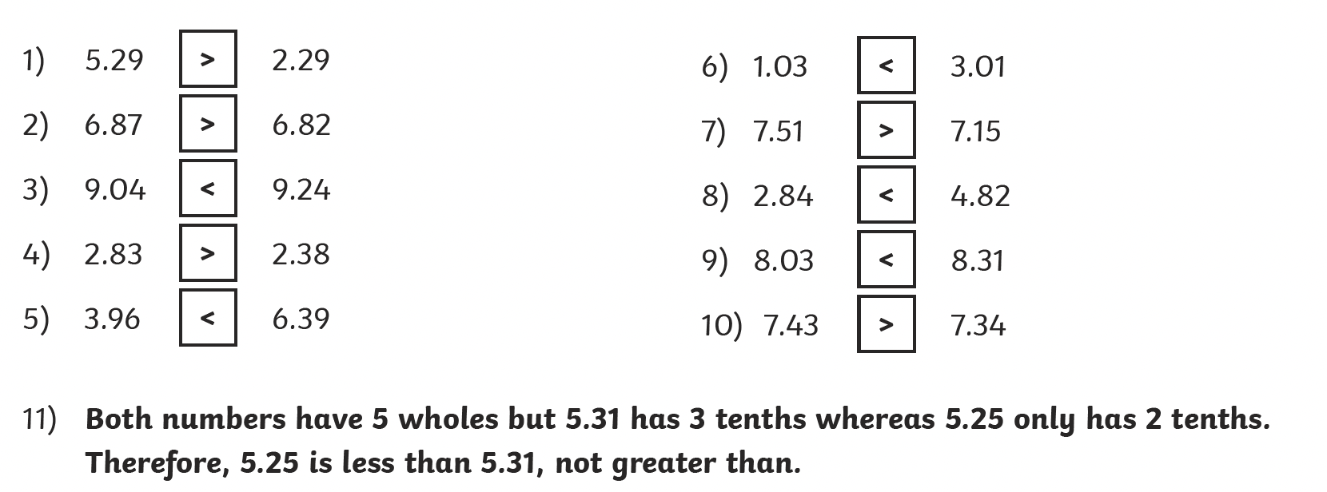

Challenge 2: Ordering and comparing decimals with up to 3 decimal places.
ANSWERS



