Y5 Maths Homework (week 14) Christmas Jokes (Addition and subtraction)
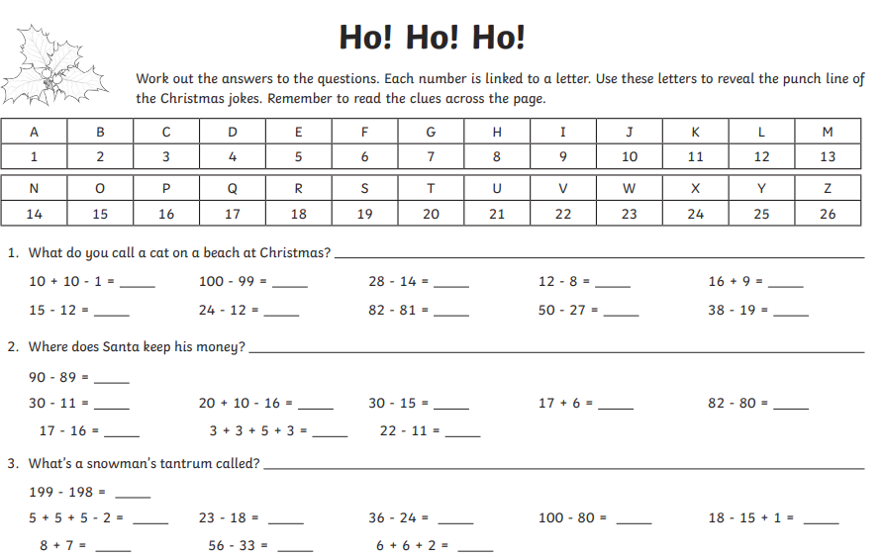
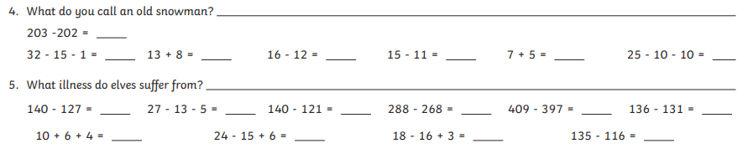
Y5 Maths Homework (week 14) Christmas Jokes (Addition and subtraction)
ANSWERS


