Y5 English Homework week 3 (19.9.24)
Please stick this answer sheet into your Homework book and then mark your work.

Subordinating Conjunctions

Underline the subordinating conjunction in each sentence.

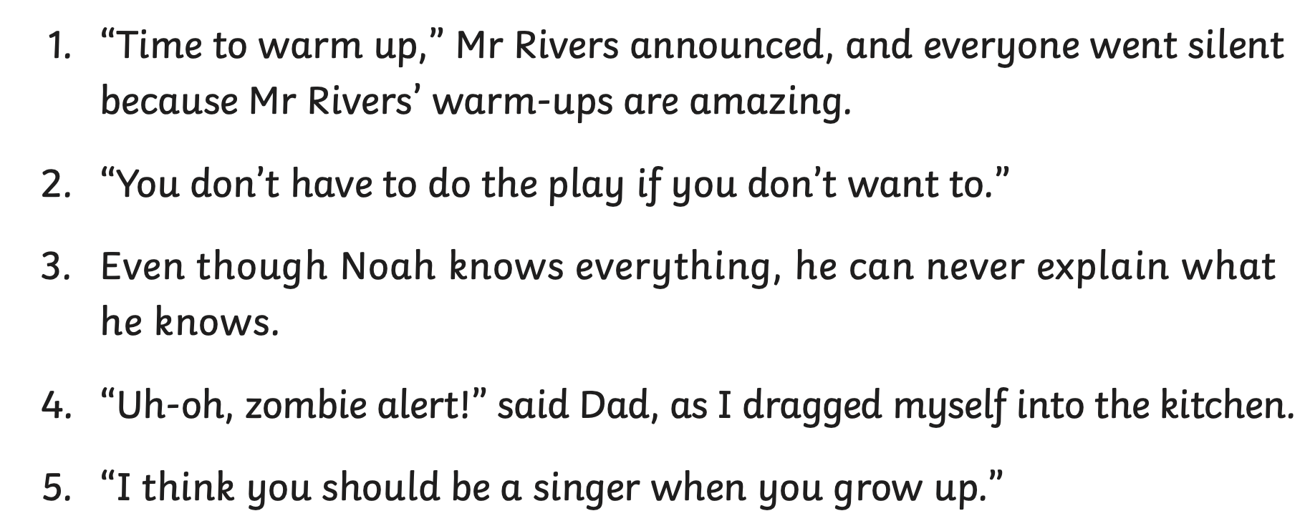

Add an appropriate subordinating conjunction into each sentence. Don’t forget to read your sentence back to check that it makes sense! Use the word bank to help you.

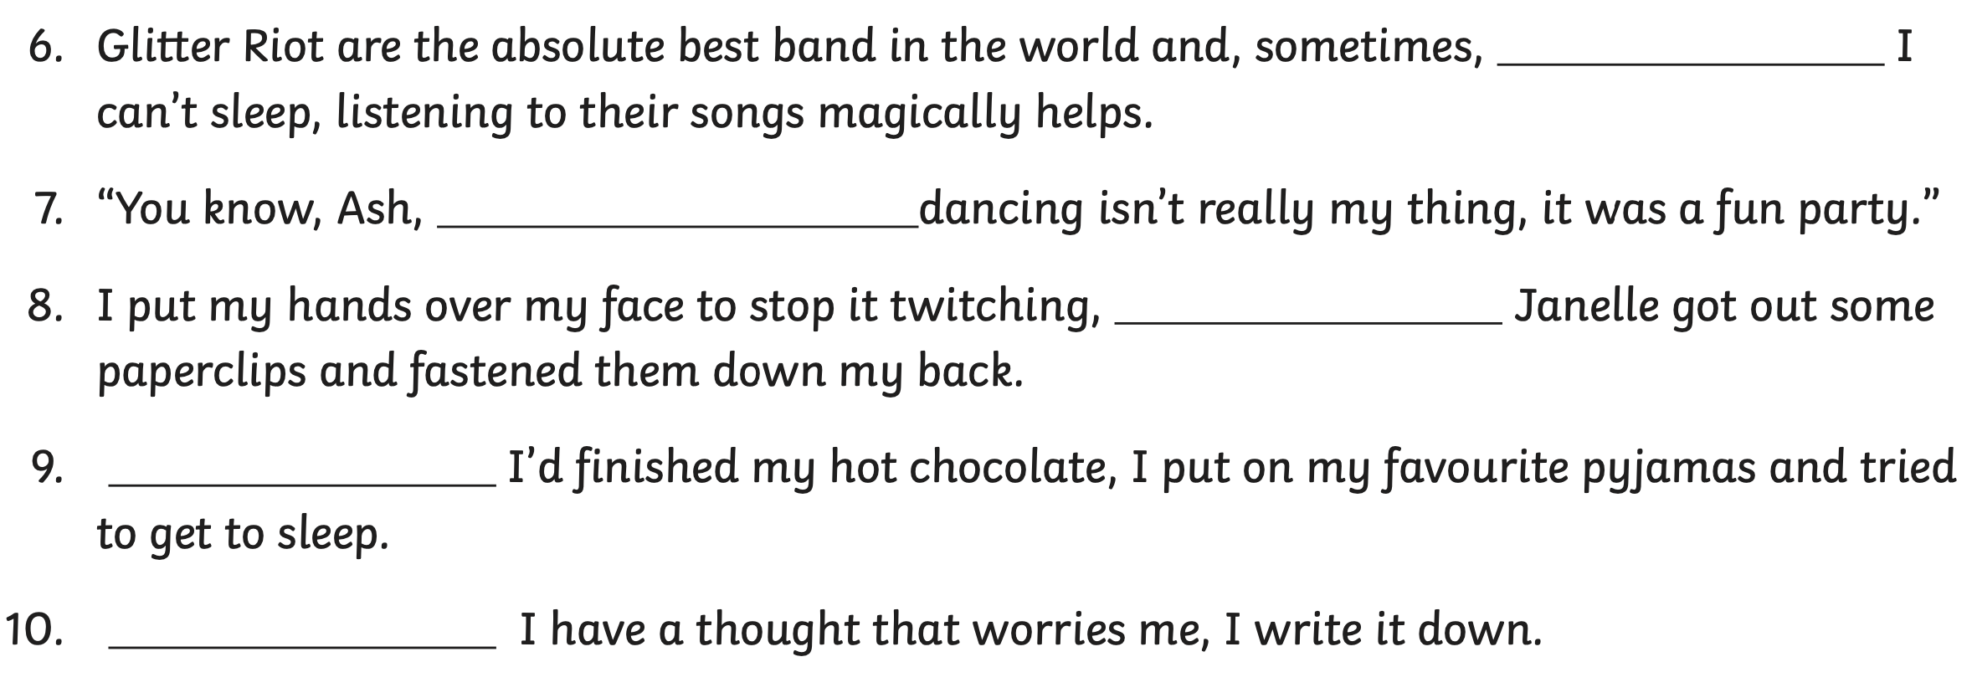
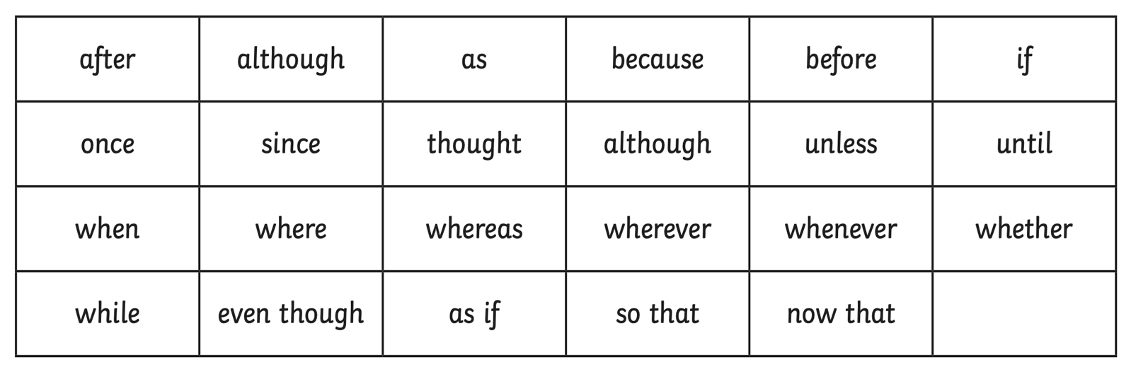
Y5 English Homework week 3 (19.9.24)
ANSWERS

Subordinating Conjunctions

Underline the subordinating conjunction in each sentence.
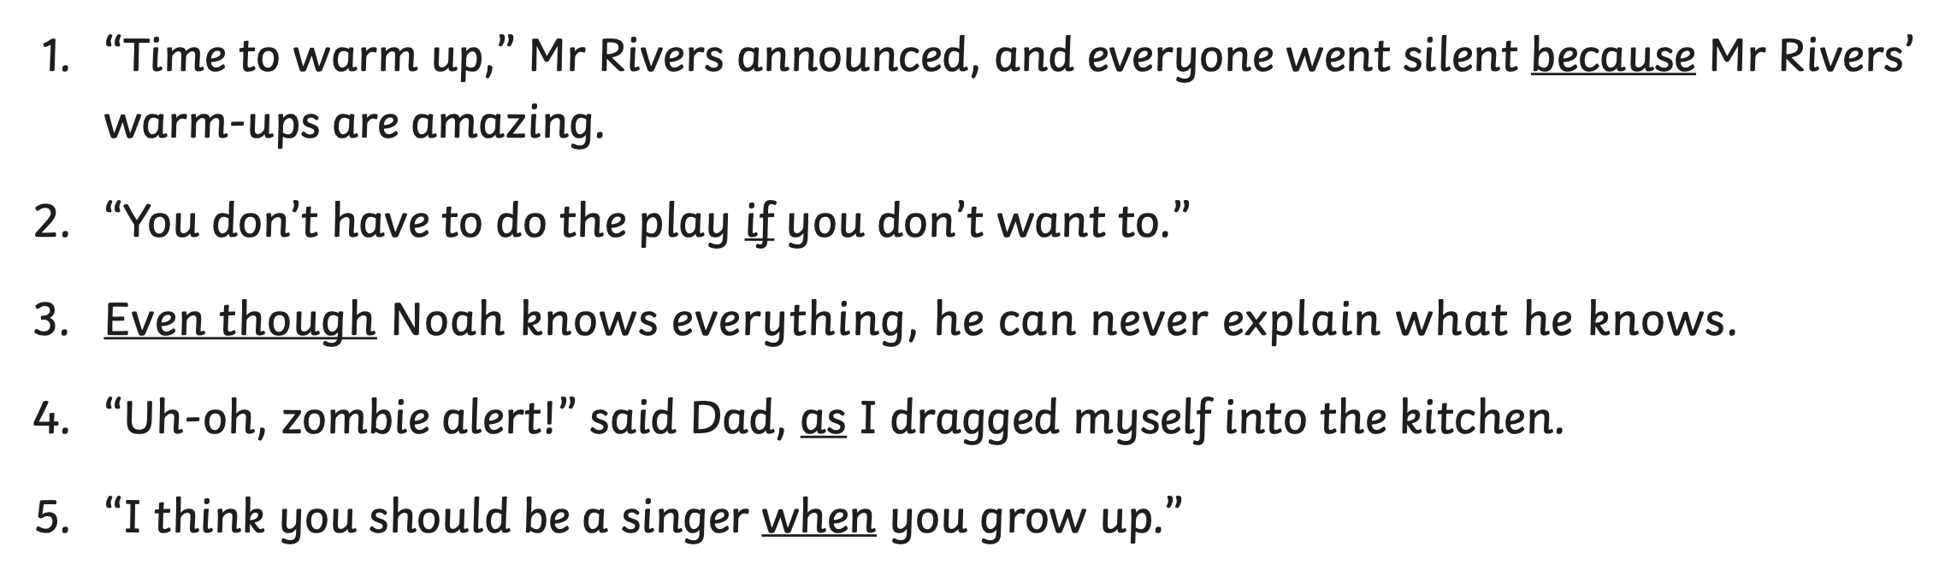

Add an appropriate subordinating conjunction into each sentence. Don’t forget to read your sentence back to check that it makes sense! Use the word bank to help you.



