Y5 Maths Homework week 3 (19.9.24)
Please stick this answer sheet into your Homework book and then mark your work.

Crossnumber Place Value to 1,000,000
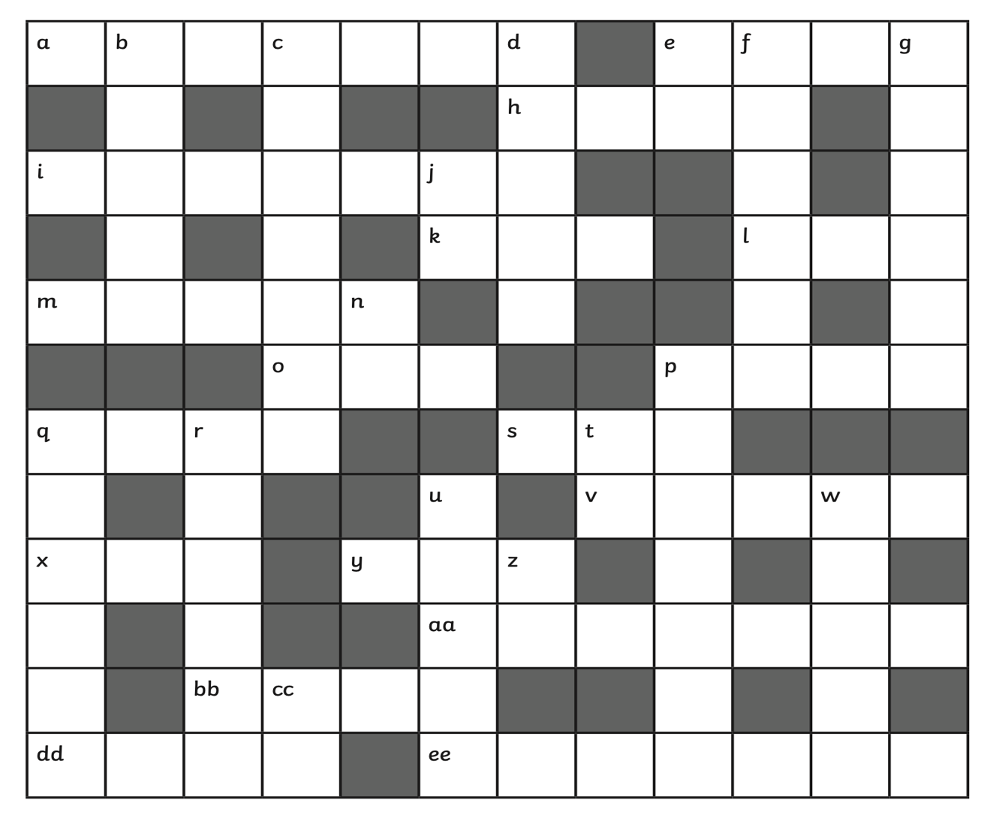

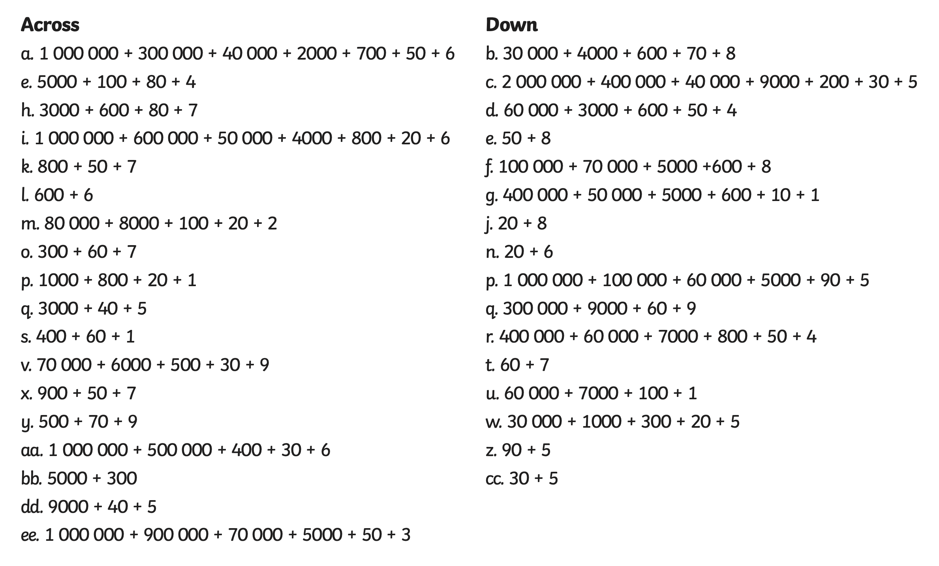

Y5 Maths Homework week 3 (19.9.24)
Crossnumber Place Value to 1,000,000
ANSWERS


