Y5 English Homework Autumn 2 week 9
Comprehension page 1
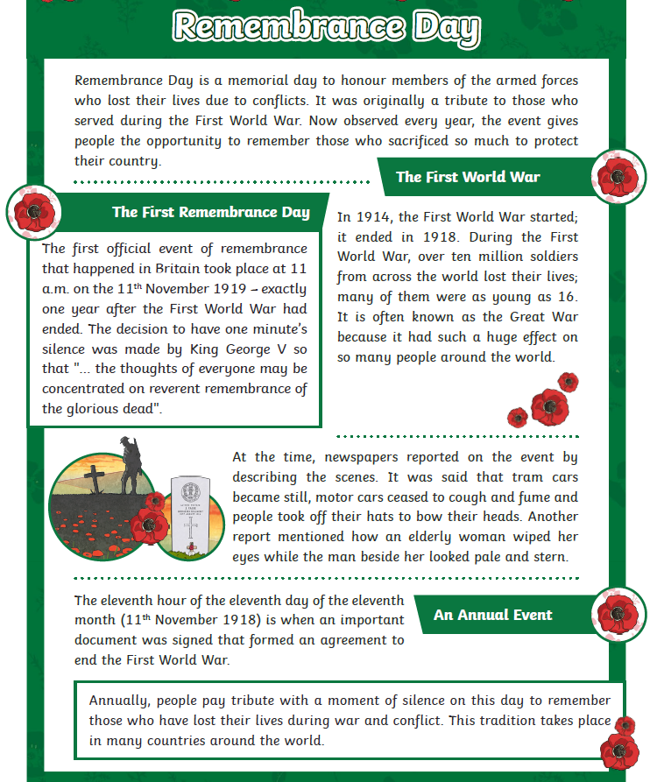
Comprehension page 2
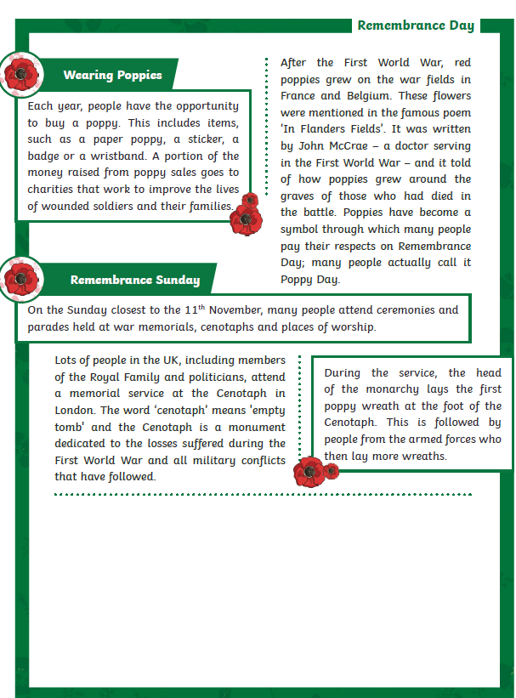

Y5 English Homework Autumn 2 week 9 Questions (Only stick this sheet in your Homework book).
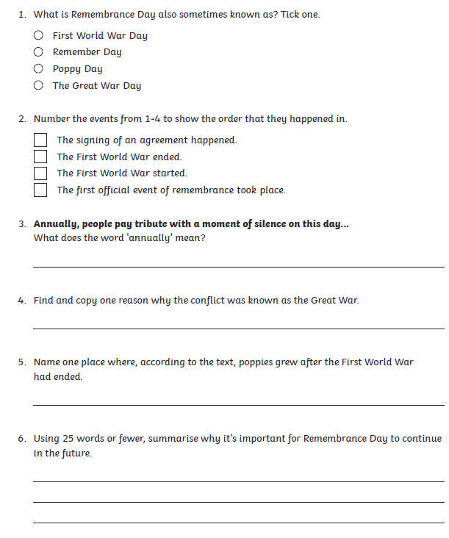
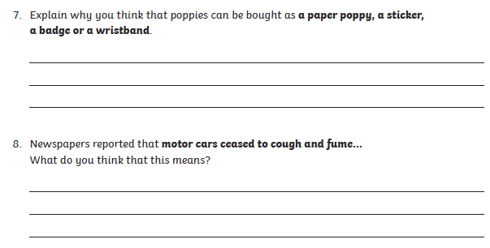
Y5 English Homework Autumn 2 week 9 Answer sheet


