Y5 Maths Homework week 8 (24.10.24)

Multiply decimal numbers by 10, 100 and 1000.
Please choose which challenge you’d like to do (you can do all three if you want) and there’s even an extra challenge on dividing decimal numbers by 10,100 and 1000 too. Once you’ve completed your wok please stick it into your Homework book and mark it using the answers which are on the Year 5 class page on the website.

Top Tip: When multiplying by 10, 100 or 1000 you are making the numbers larger so you need to move digits either 1, 2 or 3 places to the left. Draw a place value grid to support you if you need to.

Challenge 1 - Complete the table below:
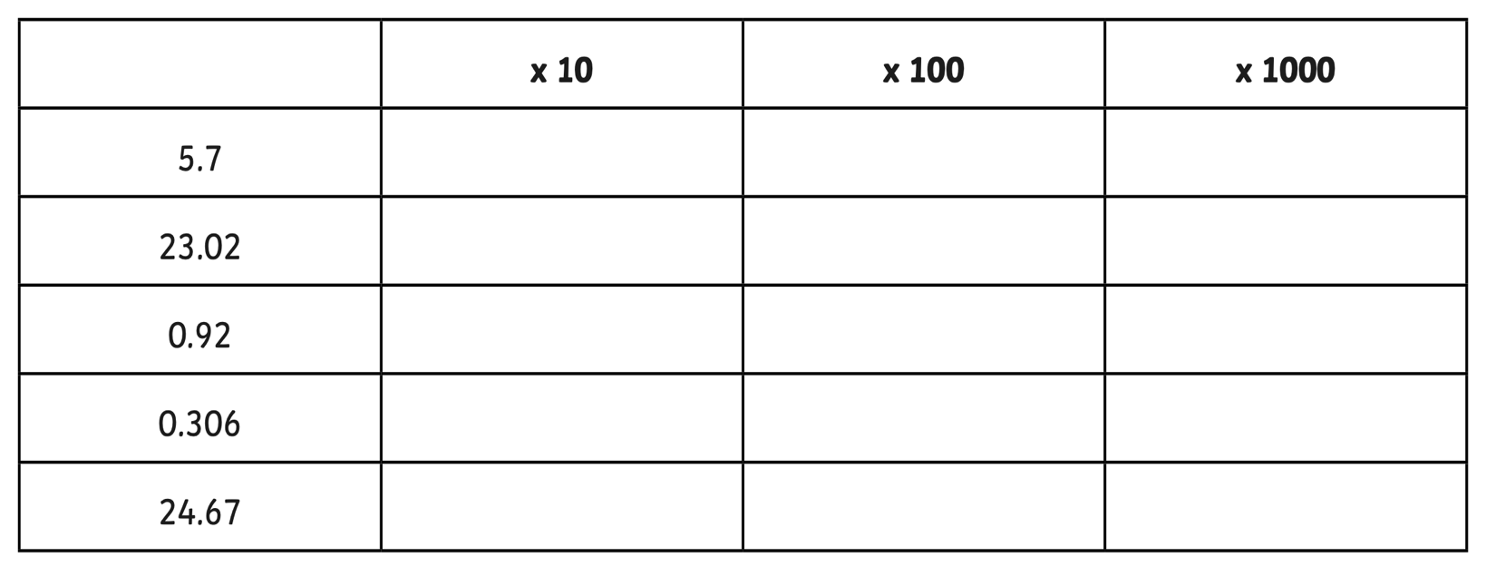

Challenge 2 - Complete the table below:

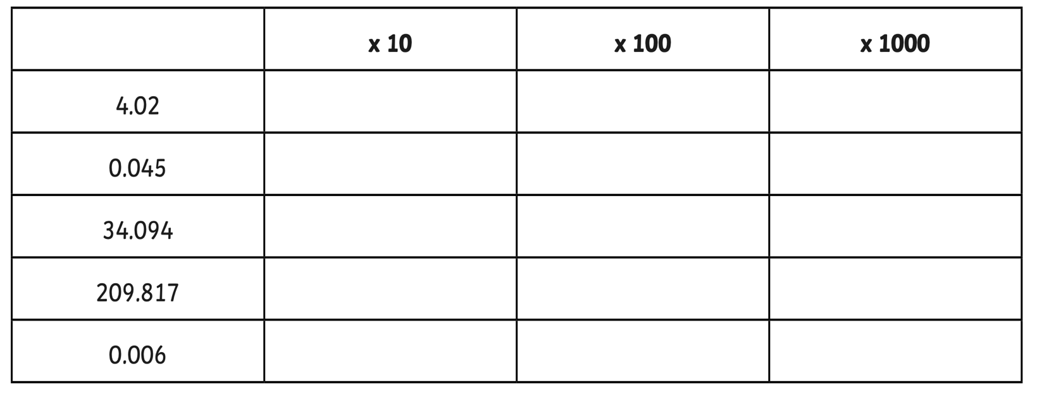

Challenge 3 - Complete the table below:

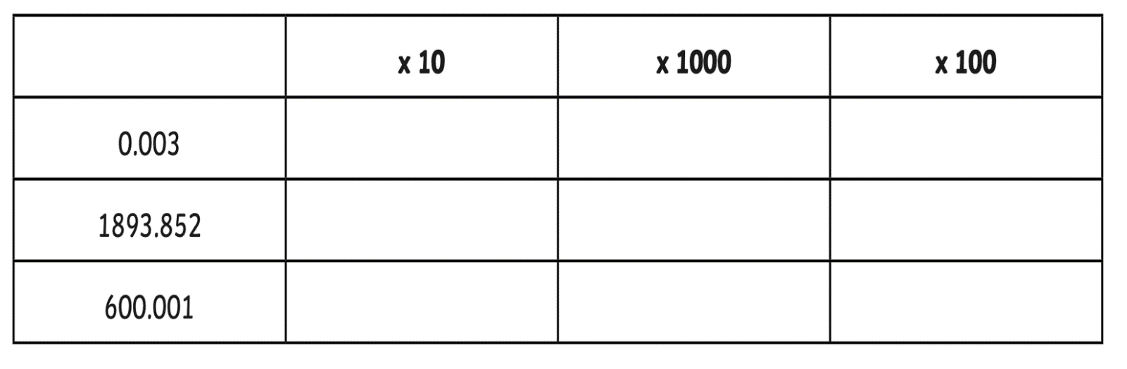

Extra challenge: divide by 10, 100 and 1000 and complete the table below:

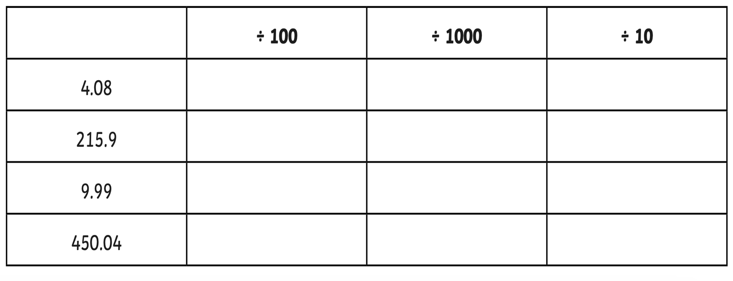

Y5 Maths Homework week 8 (24.10.24)

Multiply decimal numbers by 10, 100 and 1000 - ANSWERS

Challenge 1: ANSWERS

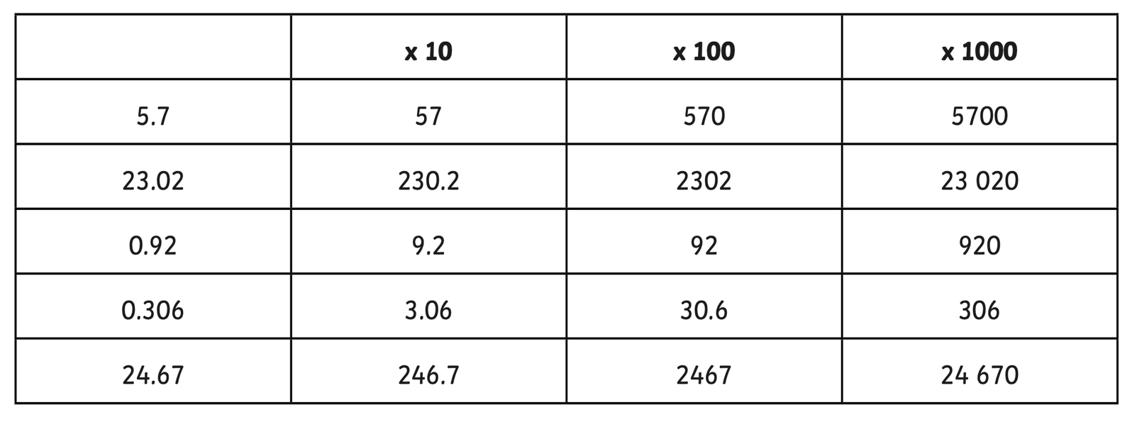

Challenge 2: ANSWERS
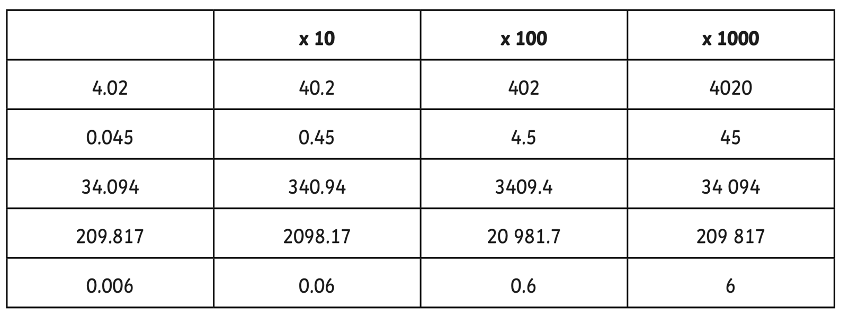

Y5 Maths Homework week 8 (24.10.24)

Multiply decimal numbers by 10, 100 and 1000 - ANSWERS

Challenge 3: ANSWERS

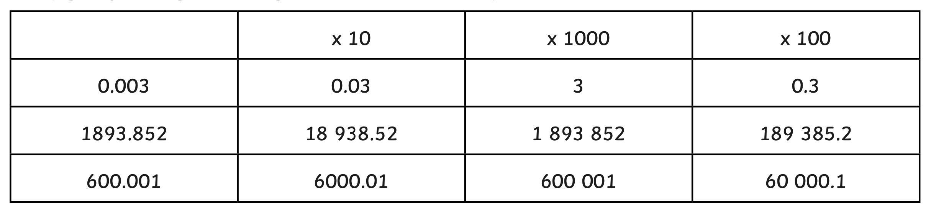

Extra challenge: ANSWERS


