Y5 Maths Homework (5.12.24)

Please choose to answer either Challenge 1 or 2 and stick the sheet into your Homework book.
There is an optional extra challenge to complete if you would like to challenge
yourself. You will need to stick this sheet in your Homework book too.
Please mark your maths and make corrections using the answer sheet from the school website
(Class News – Year 5 – Homework – week 13).

Challenge 1:
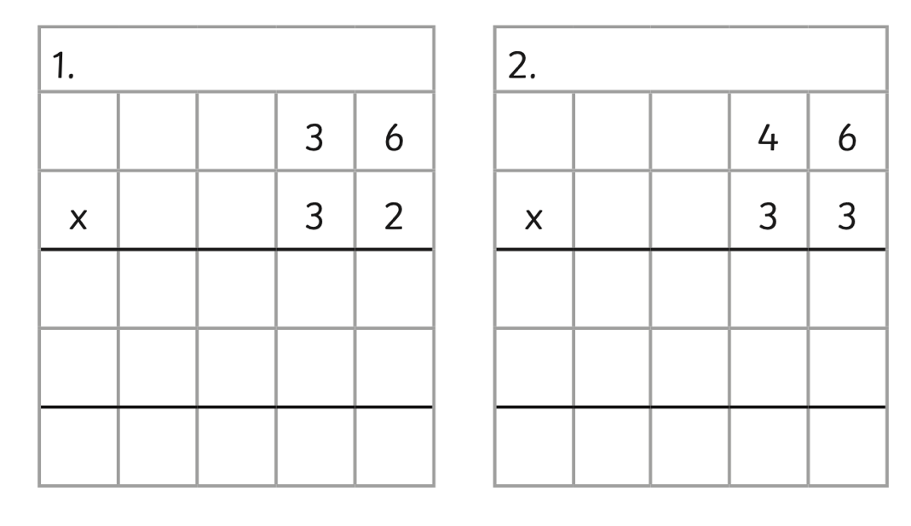

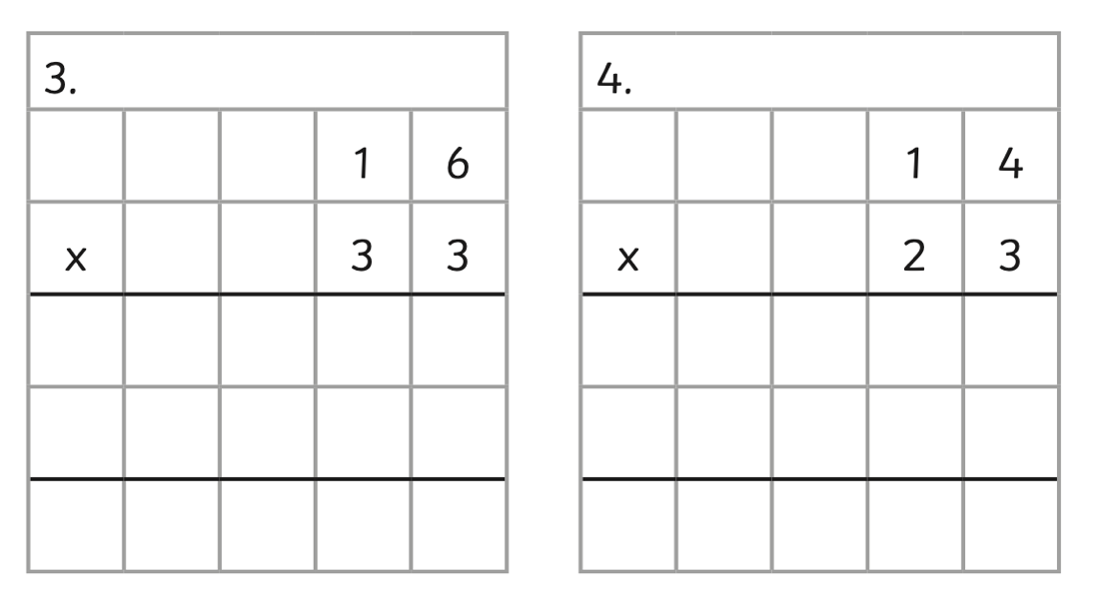

Now mark your work and make any corrections in green pen.

Y5 Maths Homework (5.12.24)
Challenge 2:

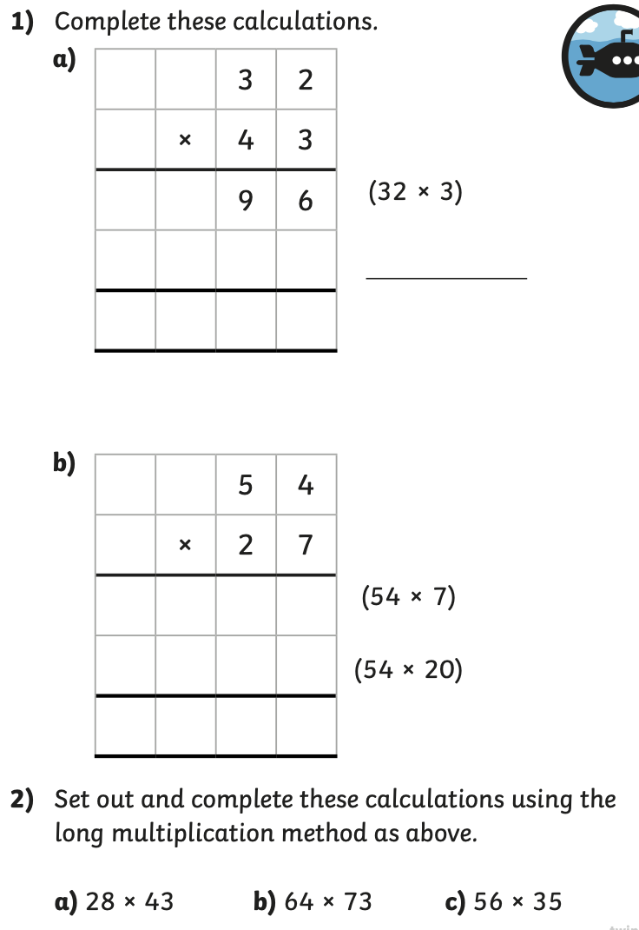

Now mark your work and make any corrections in green pen.

Y5 Maths Homework (5.12.24)
Extra Challenge:

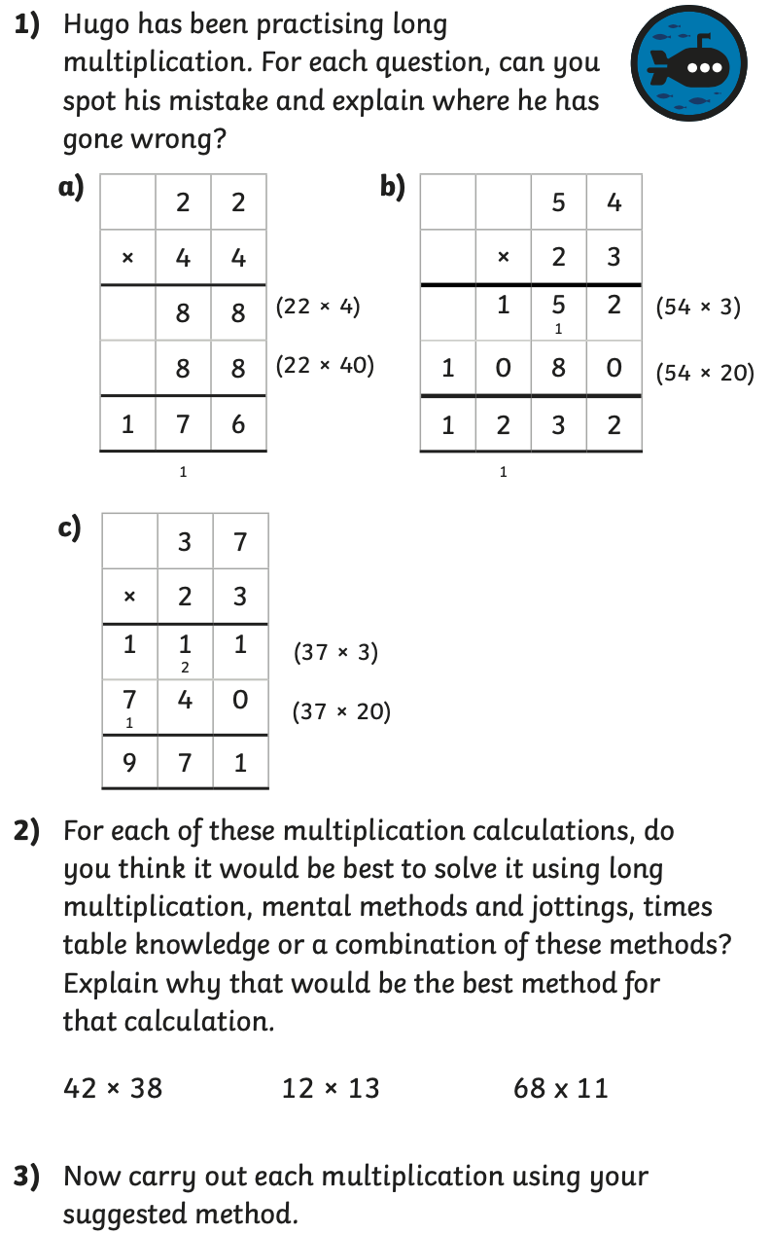

Now mark your work and make any corrections in green pen.

Y5 Maths Homework (5.12.24)
ANSWERS

Challenge 1:

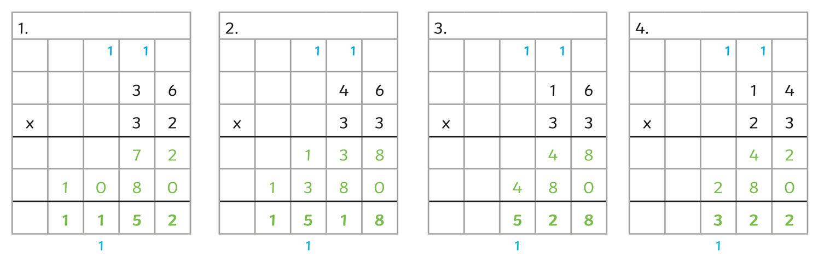
Challenge 2:

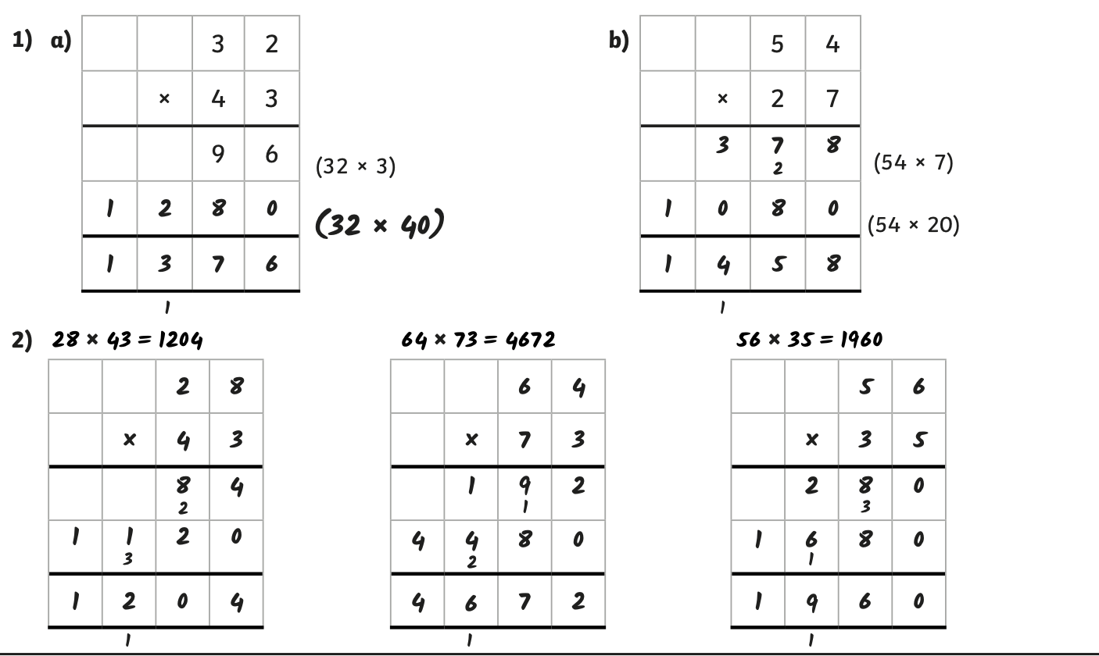

Extra Challenge:



