Year 5 Maths Homework week 5 (3.10.24)
Negative Numbers and Temperature
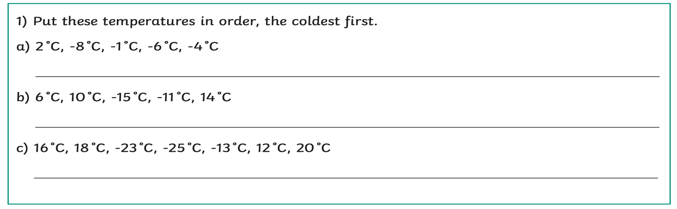
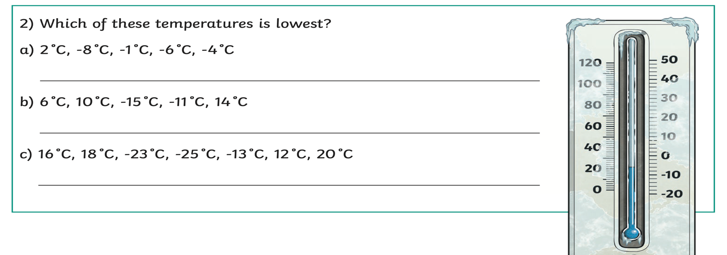
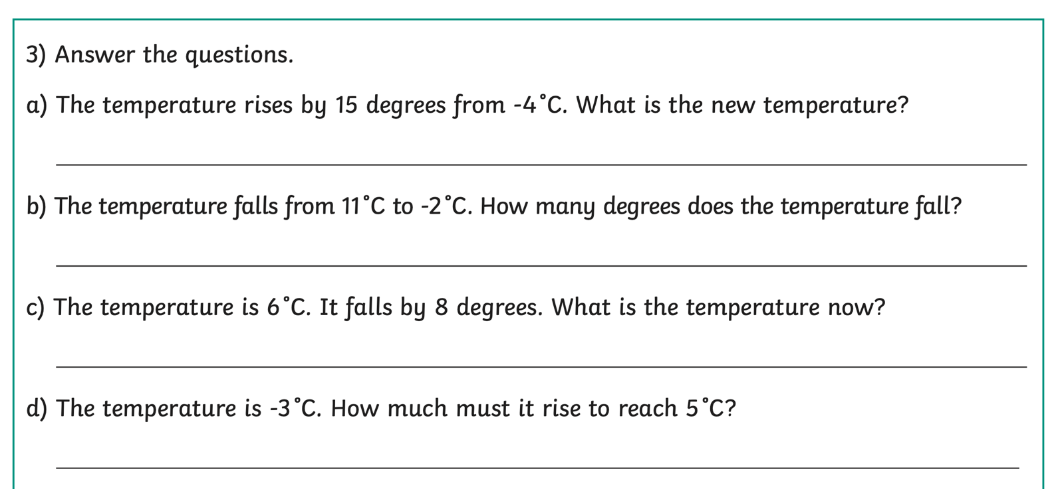

Year 5 Maths Homework week 5 (3.10.24)
Answers



