English | CURRICULUM INFORMATION  Spring 2025  YEAR 3 | Maths
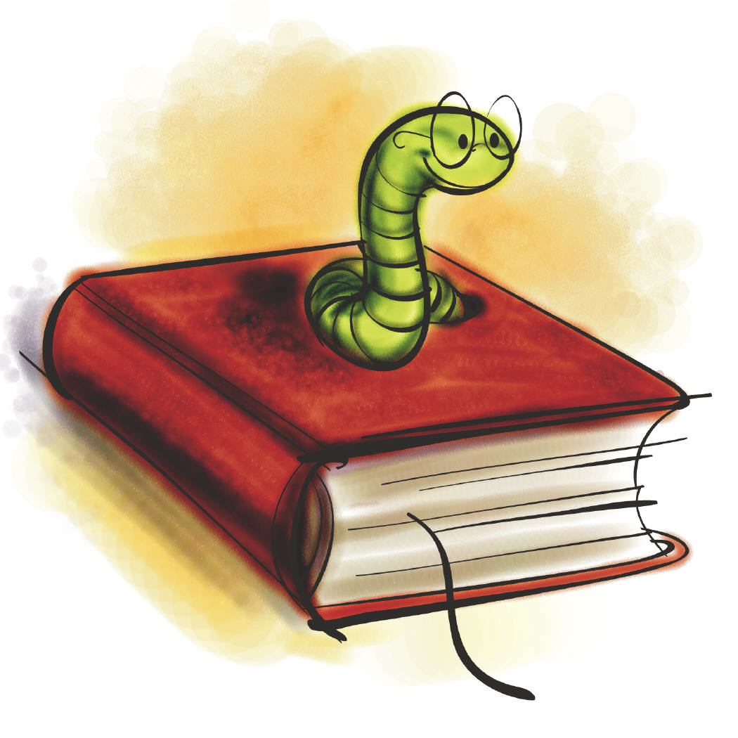  Persuasive writing  Narrative writing  Grammar focus:  - Extend the range of sentences with more than one clause by using a wider range of conjunctions, including when, if, because, although.  - Use the present perfect form of verbs in contrast to the past tense.  - Choose nouns or pronouns appropriately for clarity and cohesion and to avoid repetition.  - Use conjunctions, adverbs and prepositions to express time and cause.  - Use fronted adverbials.  - Use commas after fronted adverbials.  - Indicate possession by using the possessive. apostrophe with plural nouns.  - Use and punctuate direct speech. | CURRICULUM INFORMATION  Spring 2025  YEAR 3 | 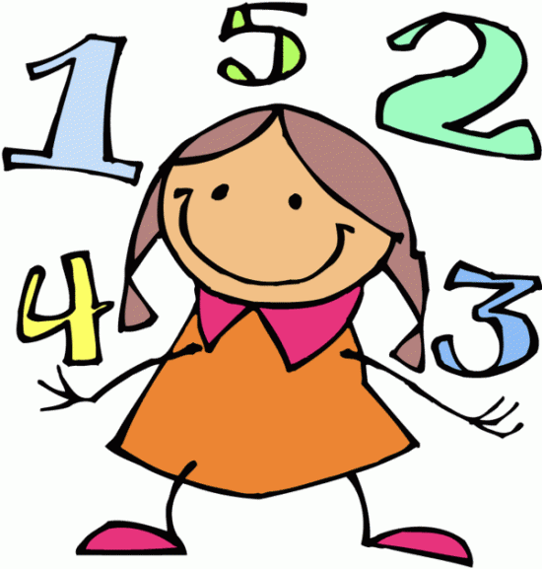  - Written addition and subtraction  - Angles  - 2D shapes  - Perimeter  - Multiplication - 3,4 &8  - Division – 1,2,3,4,5 and 8 times tables  - Multiplication and division- Worded Problems  - Fractions - Finding Fractions of Discrete and Continuous Quantities  - Ordering and comparing fractions  - Adding and subtraction fractions  - Multiplication- Formal Written Method  TT Rock Stars  Hit the Button
 | RE


Journeys
- Celebrate the key elements of Christ’s life by journeying with Christ and sharing his way of life.

Listening and Sharing
- Explore the two parts of The Eucharist celebration and listen to the Word of God and share Holy Communion.

Giving All
- Understand that Lent and Holy Week are times of giving in different ways and remembering the total giving of Jesus.

Sikhism
- Understand that a Gurdwara is a place of worship for Sikhs.

Class book:
Roman Boy – Tony Bradman

Key texts:

Persuasive: Stella and the Seagull.
Narrative: Alice’s Adventures in Wonderland.

Science | History | Music
  Forces and Magnets  - Compare how things move on different surfaces  - Notice that some forces need contact between two objects, but magnetic forces can act at a distance  - Observe how magnets attract or repel each other and attract some materials and not others  - Compare and group together a variety of everyday materials on the basis of whether they are attracted to a magnet, and identify some magnetic materials  - Describe magnets as having two poles  - Predict whether two magnets will attract or repel each other, depending on which poles are facing  Animals including humans  - Identify that animals including humans need the right types and amount of nutrition, and that they cannot make their own food; they get nutrition from what they eat  - Identify that humans and some other animals have skeletons and muscles for support, protection and movement. | 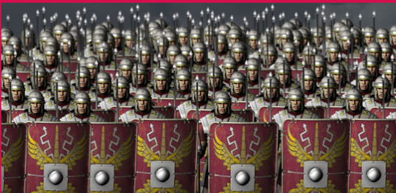  Why did the Romans settle in Britain?  - Understand why the Romans invaded Britain.  - Understand the conflict for Boudicca.  - Understand how Roman soldiers were equipped for war.  - Understand Roman army battle formations.  - Make inferences about life in Roman times.  - Identify the Roman legacy in Britain. | - Sing and improve vocal technique. Begin exploring songs with ostinato accompaniments and rounds.  - Analyse melody structure / repetition. Identify rhythms for songs aurally.  - Use ICT to compose a soundscape of repeating patterns.  - Compose a 4-bar rhythm with rhythm kits.  - Continue improving Recorder skills. Learn the notes A and C.  - Begin learning about chords and how they are written down.  - Learn to accompany songs with ukulele C and F major chords.  - Perform a melody on ukulele open strings and begin learning about “fingered” notes on the ukulele.  - Use graphic scores and other notations with increasing confidence.  - Improve understanding of musical notation and write with improving neatness.
Computing | Geography | PSHE - Jigsaw
  Touch Typing  - To understand the correct way to sit at the keyboard and how to use basic keys; home, top and bottom row keys.  - To develop touch typing by knowing names of fingers and start using two hands to type on a keyboard.  E-Mail  - To open and respond to an email.  - To write an email to someone from an address book. This will also be taught alongside revision of online safety. | 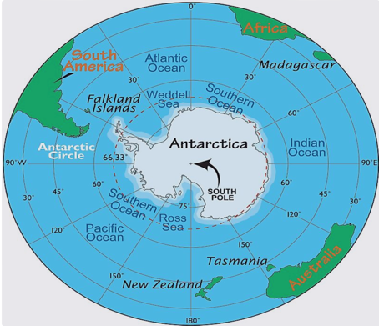  Who lives in Antarctica?  - Understand the position and significance of lines of latitude.  - Describe the location and physical features of Antarctica.  - Describe the human features of Antarctica.  - Use four-figure grid references to plot Shackleton’s route to Antarctica.  - Plan a simple route on a map using compass points.  - Follow instructions involving compass points and map a simple route. | - Dreams and goals  - Healthy me
 |  | RSE
- What am I feeling?
We examine our feelings and try to understand them and what causes them.
- What am I looking at?
We compare our own life experiences to what we see through fake reality presented to us by television, magazines, and adverts.
- I am thankful.
We identify that particular feelings and actions may make us act inappropriately and so we learn how to build resilience in various ways, including choosing to be thankful.
- Life cycles.
We explore the nature of human conception and birth through the knowledge that we were handmade by God with our parents’ help and end with a thanksgiving meditation.
Creative – Art/D&T | Spanish | PE
  Art  - Ancient Egyptian Scrolls – Developing design and craft skills taking inspiration from Ancient Egyptian art and pattern making.  D&T  - Structures: Constructing a castle Identify and learn about the key features of a castle, before designing and making a recycled-material castle (structure). | 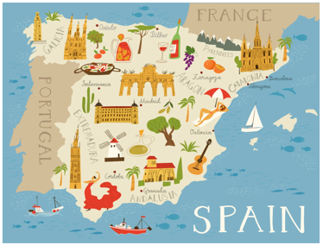  Los animales (Animals)  - Through the Language Angels scheme of work, learn 10 familiar animals and be introduced to the 1st person singular verb ‘I am’ in Spanish.  Las estaciones (Seasons)  - Learn the four seasons of the year and say which is our favourite season and why. | Spring 1  - Dodgeball  - OAA  Spring 2  - Tennis  - Tag Rugby

Our PE days are: Monday and Wednesday

Homework – weekly Thursday to Tuesday

