English | CURRICULUM INFORMATION  Spring 2025  YEAR 5 | Maths
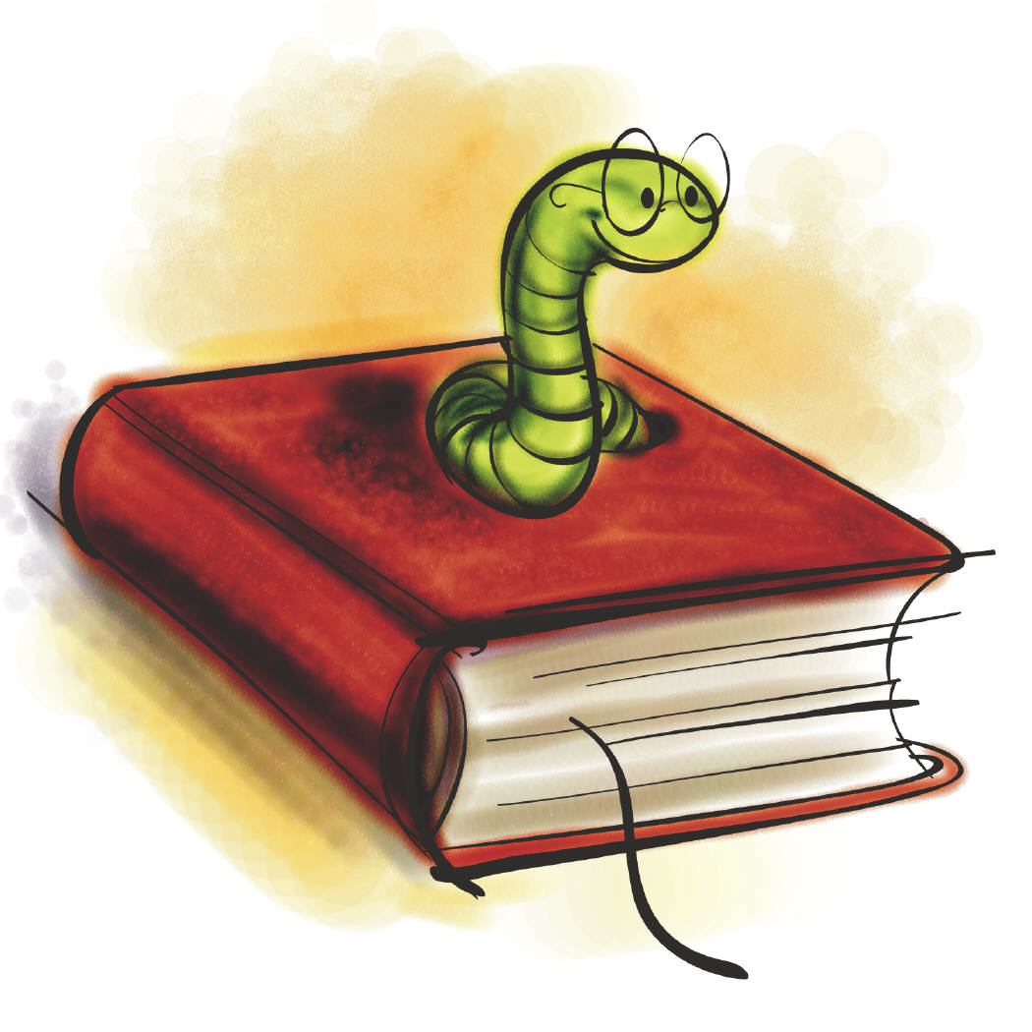  Persuasive Letters  Non-chronological reports  Descriptive recount  Narrative: Mystery & Suspense  Poetry: Take One Poet - Rap  Grammar focus:  - Use of commas in lists  - Use a range of conjunctions, prepositions and adverbials  - Apostrophe use and speech punctuation  - Use fronted adverbials  - Use relative clauses  - Use hyphens  - Use brackets, dashes or commas for parenthesis  - Use direct or reported speech.  Oracy Focus:  - Perform own compositions using appropriate intonation, volume and movement so that the meaning is clear. | CURRICULUM INFORMATION  Spring 2025  YEAR 5 |   Problem Solving (four operations)  Multiplication & division  Multiplying fractions  Fraction problem solving  Measure  Area  Volume and capacity  Percentages  Problem solving (percentages)  3D shape  Reflection/translation  Perimeter  Angles  TT Rockstars
 | RE


Topic 4: Mission (Community)
- Know that Jesus undertook his mission to share the good news and that each diocese continues with that mission and work today.

Topic 5: Memorial Sacrifice (Eucharist)
- Have an understanding of scripture, belief and experiences about the Jewish Passover, the Last Supper and celebration of the Eucharist.
- How the sacrifice of Jesus shapes the lives of Christians.

Topic 6: Sacrifice (Lent/Easter)
- Know and make links between the scripture stories of Holy Week and the Temptation on the desert.
- How Christians observe the season of Lent.
- Understand the sacrifice Jesus made and how the Resurrection shapes lives.

World Religion: Hinduism
- Know that the god Brahman is important to Hindus.
- Know that pilgrimage is an important part of life to Hindus

Class book: The Explorer by Katherine Rundell
Key texts:
The Misadventures of Frederick
The Skies Above My Eyes, The Street Beneath My Feet & The Sea Below My Toes
The Water Tower
Boy in the Tower
Poetry: Rhythm & Poetry
Science | History | Music
  Forces  - Explain that unsupported objects fall towards the Earth because of the force of gravity acting between the Earth and the falling object  - Identify the effects of air resistance, water resistance and friction, that act between moving surfaces  - Recognise that some mechanisms, including levers, pulleys and gears, allow a smaller force to have a greater effect.  Properties and Changes of Materials:  - Compare and group together everyday materials on the basis of their properties, including their hardness, solubility, transparency, conductivity (electrical and thermal), and response to magnets.  - Know that some materials will dissolve in liquid to form a solution, and describe how to recover a substance from a solution.  - Use knowledge of solids, liquids and gases to decide how mixtures might be separated, including through filtering, sieving and evaporating.  Give reasons, based on evidence from comparative and fair tests, for the particular uses of everyday materials, including metals, wood and plastic.  Demonstrate that dissolving, mixing and changes of state are reversible changes.  - Explain that some changes result in the formation of new materials, and that this kind of change is not usually reversible, including changes associated with burning and the action of acid on bicarbonate of soda. |   Focus: How did the Maya civilisation compare to the Anglo-Saxons?  - Who were the Maya and when did they live?  - How did the Maya settle in the rainforest?  - What similarities and differences existed between Maya and Anglo-Saxon homes?  - What did the Maya believe?  - What do archaeological remains tell us about Maya cities?  - Was the decline of the Maya cities man-made or a natural disaster? | - Improve understanding of rhythms and notation, including simple time (semiquavers) and compound time. Learn more about time signatures.  - Use ICT to explore modes on piano app white notes.  - Identify rhythms aurally.  - Analyse musical notation and perform a melody on chime bars.  - Improve ukulele skills: perform melodies on open strings and using some fingered notes.  - Learn to improvise melodic or rhythmic music.  - Use ICT to perform a melody (Frere Jacques etc) on piano app.  - Learn additional chords on the ukulele.  - Compose a short melody for ukulele open strings.  - Analyse structure of repetition / variation; instruments / doubling. Improve understanding of call & response.  - Compose music with two or four parts.  - Recognise the effects of tempo and dynamic changes.  - Compose music with a call & response structure.  - Learn about orchestral instruments and families.  - Listen to music with attention to detail.
Computing | Geography | PSHE
  - Spreadsheets  - Databases | 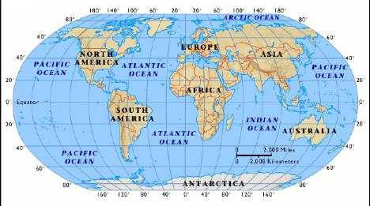  Focus: Why do oceans matter?  - How do we use our oceans?  - What is the Great Barrier Reef?  - Why are our oceans suffering?  - What can we do to help our oceans?  - How littered is our marine environment (Part 1)?  - How littered tis our marine environment (Part 2)? | - Jigsaw: Dreams and Goals  - Jigsaw: Healthy Me
Creative – Art/D&T | Spanish | PE
  Art  - I need space - Drawing.  D&T  - Electrical systems – Doodlers. | 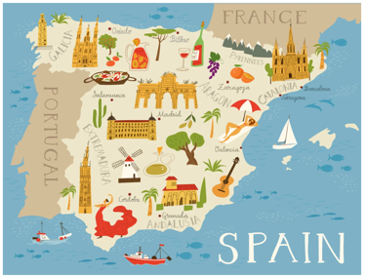  Los Helados (Ice creams)  Through the Language Angels scheme of work, you will be learn ten flavours of ice-cream and know how to buy one in Spanish and say how many scoops you would like in the flavour(s) of your choice.  Me presento (Presenting myself)  Through the Language Angels scheme of work, you will learn basic greetings, how to ask somebody their name how old they are & where they live and counting from 11-20. | Spring 1  - Gymnastics  - Basketball  Spring 2  - Gymnastics  - Tag Rugby

Our PE days are: Wednesday & Thursday.

Homework – weekly Thursday to Tuesday – Spellings and Reading.

