Homework
Year 1

Thursday 2nd March

Please complete and return work completed in your homework book on Tuesday.

Dear Parents,
Please find below our homework for this week
Reading
Please remember to read with your child daily and support them with understanding through comprehension of the text and not just decoding.
English-
We have been looking at a free verse poem this week.
Task
Using the same style (I will attach a copy of the original)
Can you write a free verse for another animal? Remember to think of things that scare them and things that they like to eat.

Maths-
This week we have been looking at word problems and finding the start, change and result.
Task
Can you have a go at these word problems writing the answers in a bar model and number sentence.

Spellings see list attached – e-e

Home learning Activity Grid – Please check what activity you would like to complete this week.

Reminders
- Reading Records to be in every day. They will be changed on a Monday, Wednesday and Friday. They need to be placed in the box as soon as the children come into the classroom for them to be changed.
-Homework goes out on a Thursday and needs to be retuned on a Tuesday
- Aprons for Art and DT to be left in lockers
- PE – Monday and Friday

Thank you for your continued support.
Miss Axon & Mrs Nicolin
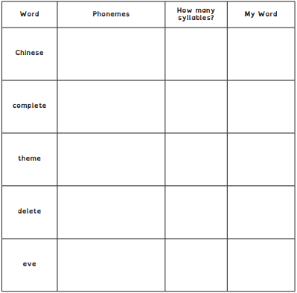

One Silver Speck

Sniff right
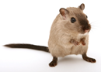
Cats? People?
Tremble, scurry
Shiver, quiver, mouse

Sniff left
Crumbs! Cheeses!
A pleasing feast-
Hurry, furry mouse!

By Laura Purdie Salas

MATHS

- Raheem has 7 football cards. His dad bought
him 12 more. How many does he have in total now?

- Nadia was given 13 beads to finish a necklace.
She already had 5 beads. How many beads does she have altogether for her necklace?

- Maddi has 6 hair bands. Her granny bought her 12 more. How many does she have in total now?

- Maria was building a tower. So far, it had 13 bricks. Andrew added 4 more bricks and Ben added 1 more. How many bricks are in the tower now?

