Homework
Year 1

Thursday 6TH October

Please complete and return work completed in your homework book on Tuesday.

Dear Parents,
Please find below our homework for this week

Reading
Please remember to read with your child daily and support them with understanding through comprehension of the text and not just decoding.
English:
This week in English we have been look at voices in the park.
TASK :
Please can you discuss a trip that you have taken recently to the park. Can you note down anything you done? (we will be sharing these to help with our writing) Could be played football, played on the swings, ran with your friends as fast as you could or simple enjoyed a walk looking at the wonderful Autumn leaves and colours.
Maths:
Task:
Please have a go at one of the activity mats below. I have attached 3 different ones Lemon and herb
Medium
Hot
They can choose which colour challenge they want to complete.
Home learning Activity Grid – Please check what activity you would like to complete this week.
Project – A reminder that your topic Homework Project for this term has been set and needs to be returned by week beginning 18th October.

Reminders
- Reading Records to be in every day. They will be changed on a Monday and Thursday. They need to be placed in the box as soon as the children come into the classroom for them to be changed.
-Homework goes out on a Thursday and needs to be retuned on a Tuesday
- Aprons for Art and DT to be left in lockers
- PE – Monday and Tuesday – These can be left in lockers

Thank you for your continued support.
Miss Axon & Mrs Nicolini

Lemon and herb
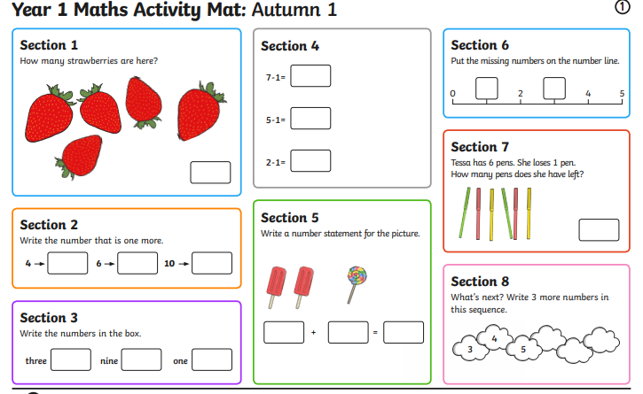

Medium
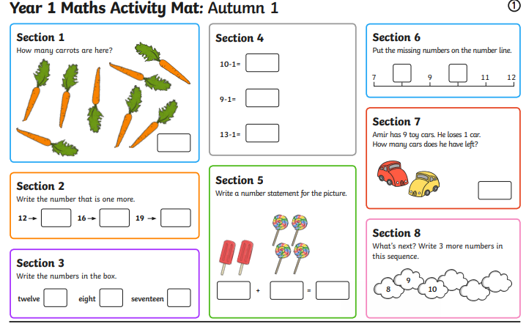

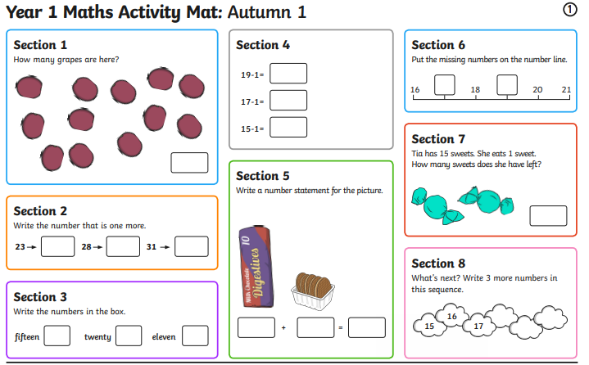
HOT

