SPELLINGS
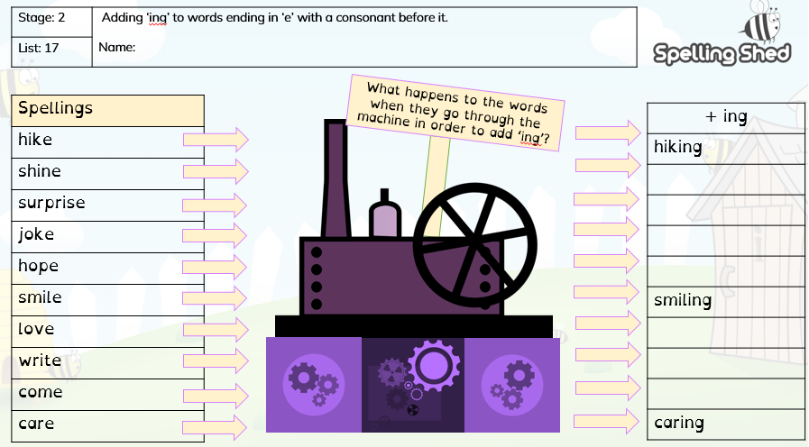
Choose 5 words and put them into sentences. e.g: I was smiling at the boy

