Maths Homework – 21.05.2026
Q1.
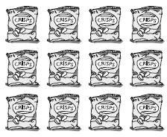
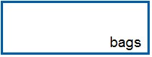
A shop has 12 bags of crisps.

It sells of the bags.
How many bags of crisps did the shop sell?

Q2.
Shade of this shape.
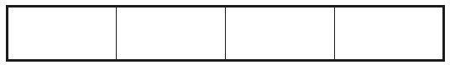
Q3.

Ben ate half a pizza.
Which fraction shows the amount he ate? 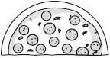
Circle it.

Q4. Circle of the apples below.

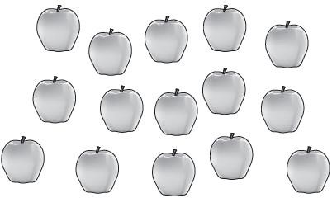
Q5. Draw lines to divide the rectangle into quarters.
Use the dots to help you.
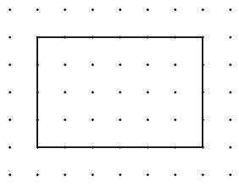
Q6.

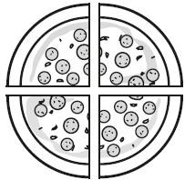
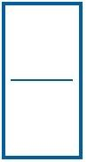
Sita cuts a pizza into four equal slices.

She eats one slice.
What fraction of the pizza does she eat?

Q7.

Tick the shape that has exactly shaded.
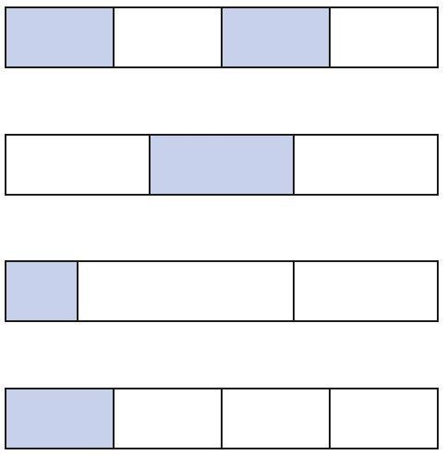
Q8.

Abdul has some toy cars.
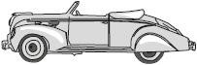
He gives half of them to Ben.

He has four toy cars left.
How many toy cars did Abdul start with?


