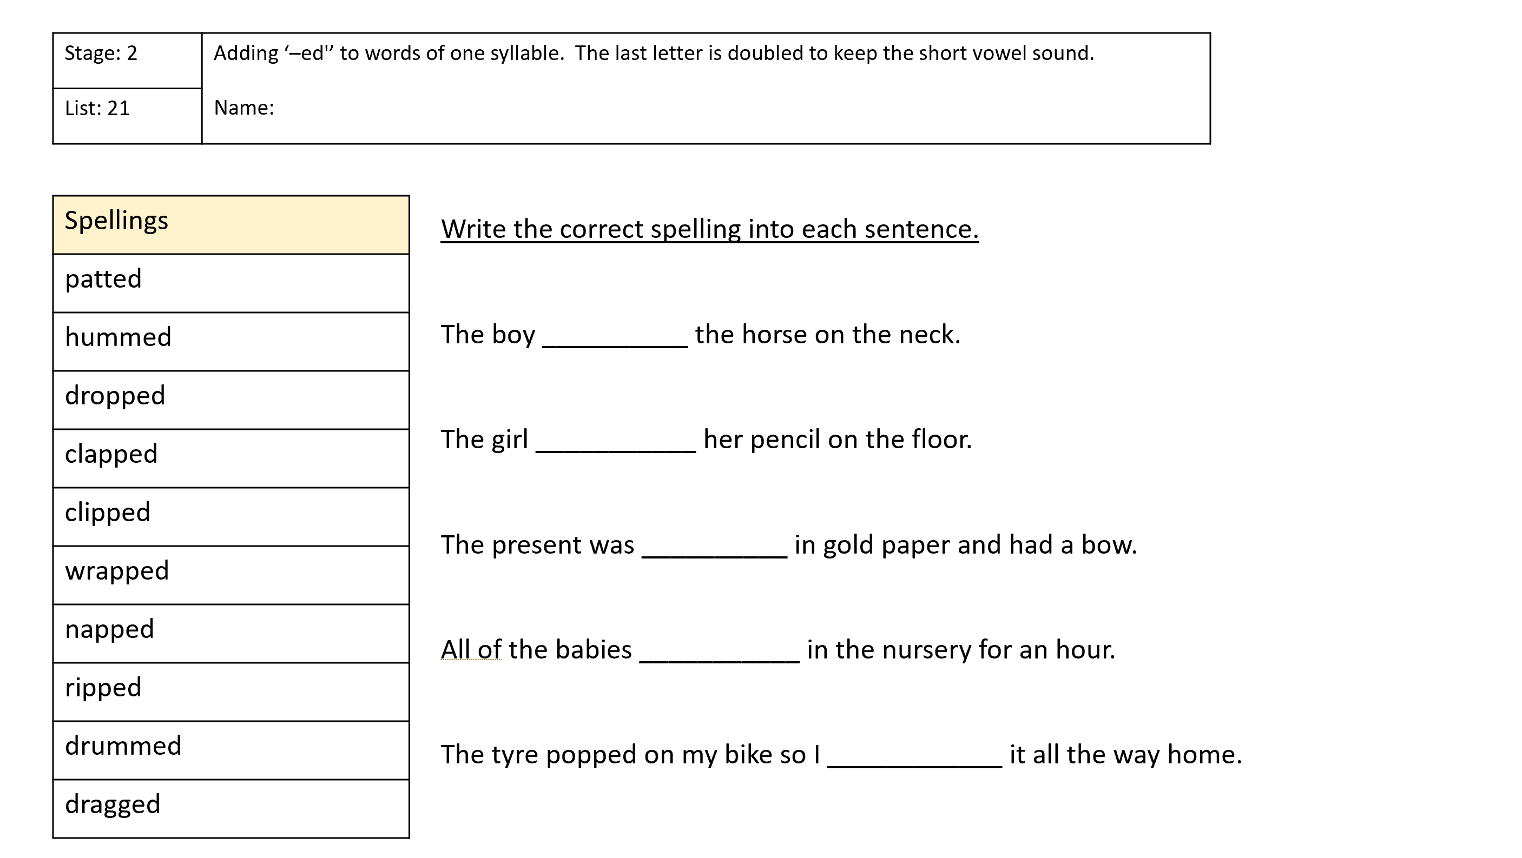
Choose 5 words and put them into a sentence.

