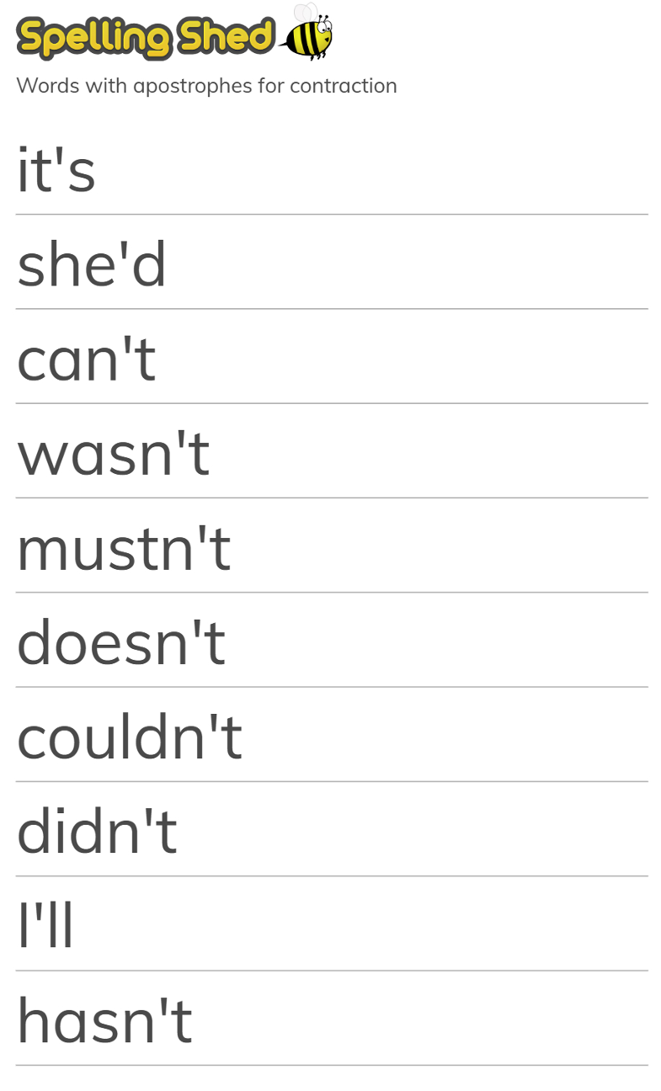
Spellings – 16.06.2026

Choose 5 words and write them in a sentence.

