Spellings:

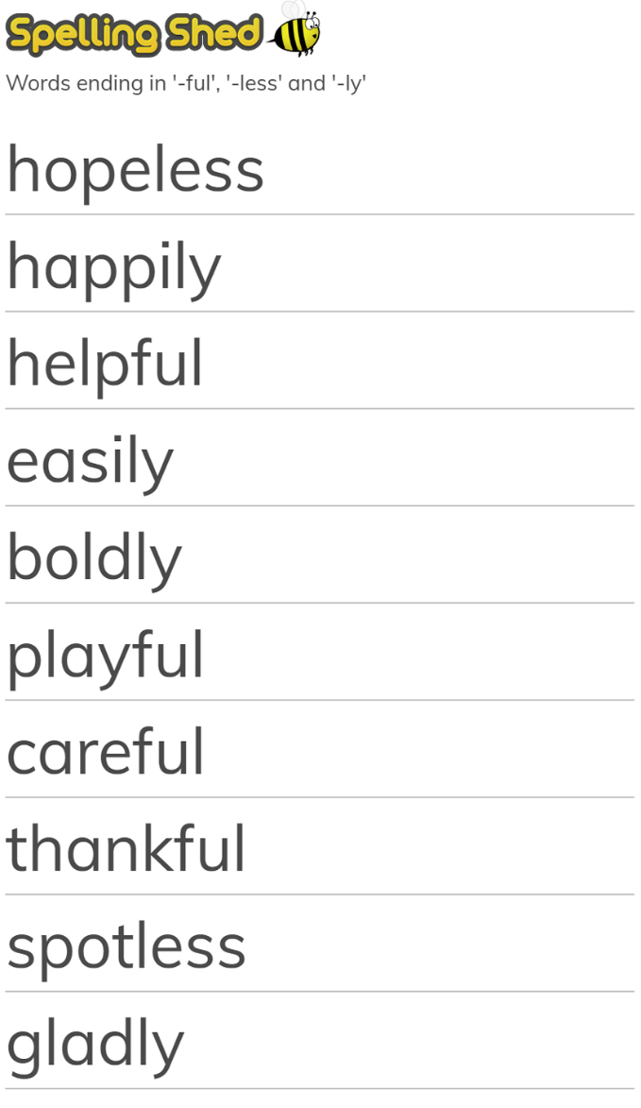
Choose 5 words and write them in a sentence.

