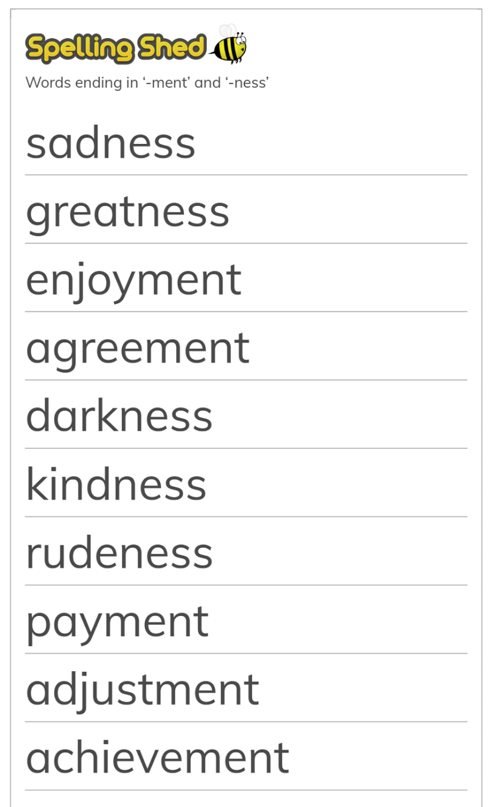
Choose 5 words and write them in a sentence:

